Admin Documentation

1. **Login Page**:

**URL: https://afrebay.com/admin/**

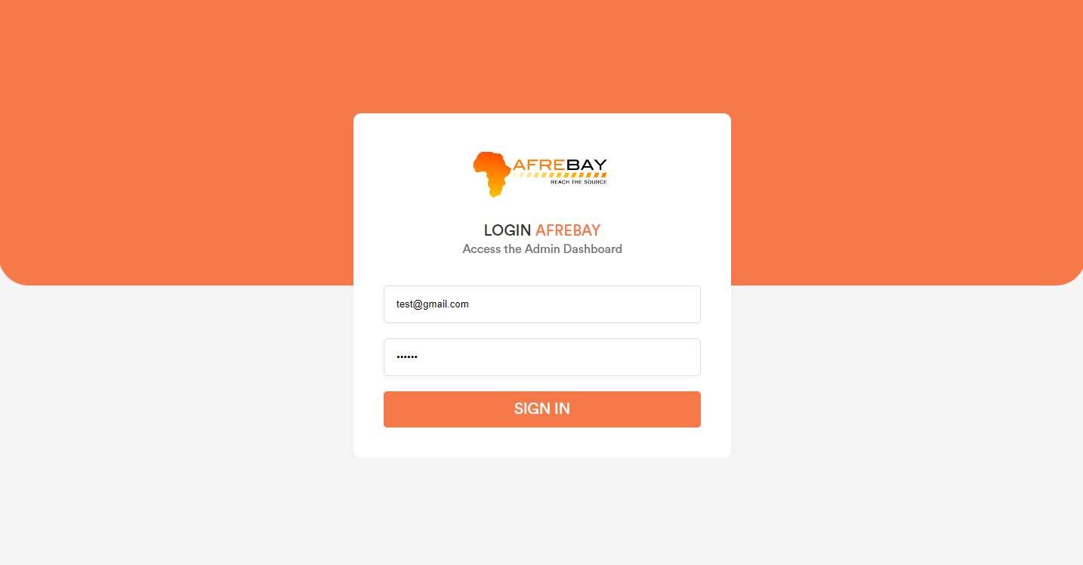

1. **Dashboard:**

After login into the admin panel user will be redirect to the dashboard page.

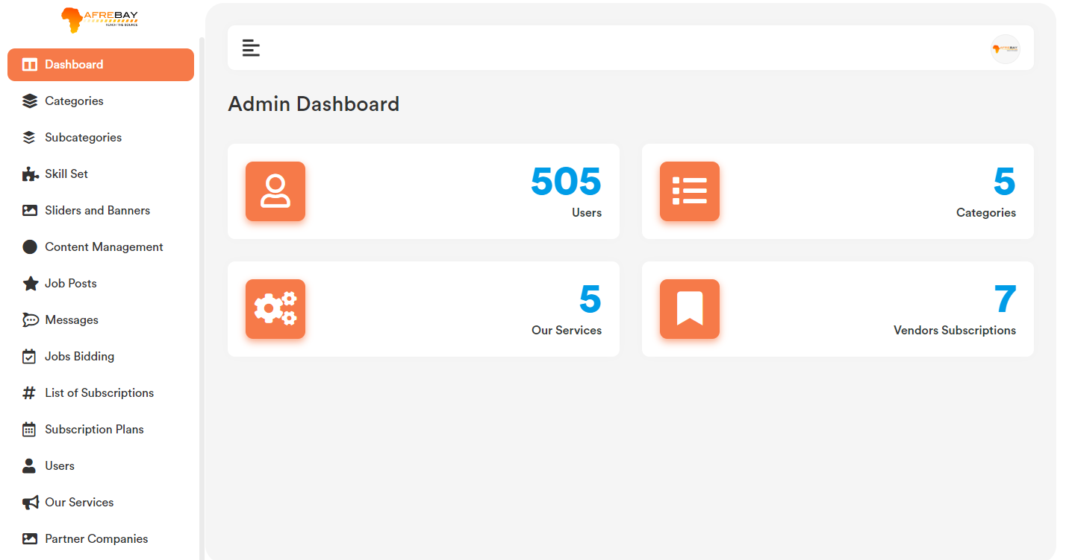

1. **Category:**

Category added by admin will show in the website frontend, once vendor will try to add a job post.

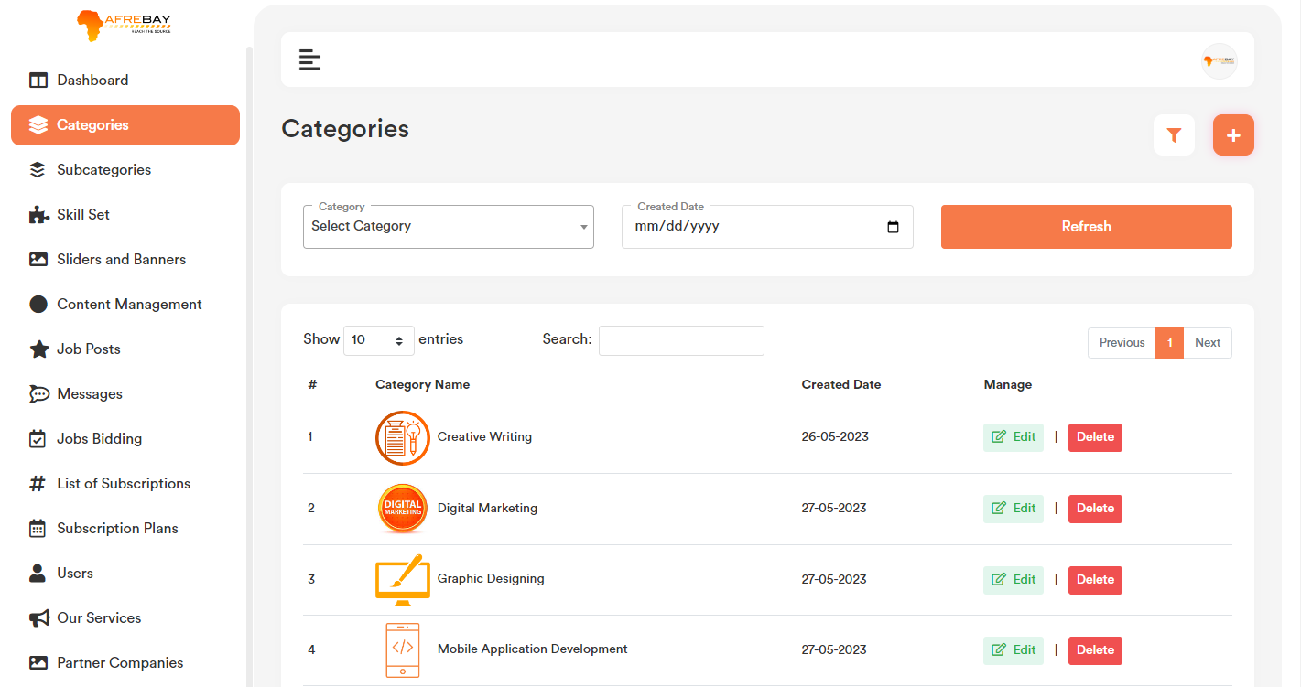

1. **Add Category:**

Category list page top right corner click on the “+” icon. User will get a form to add new category. Please check the below screenshot.

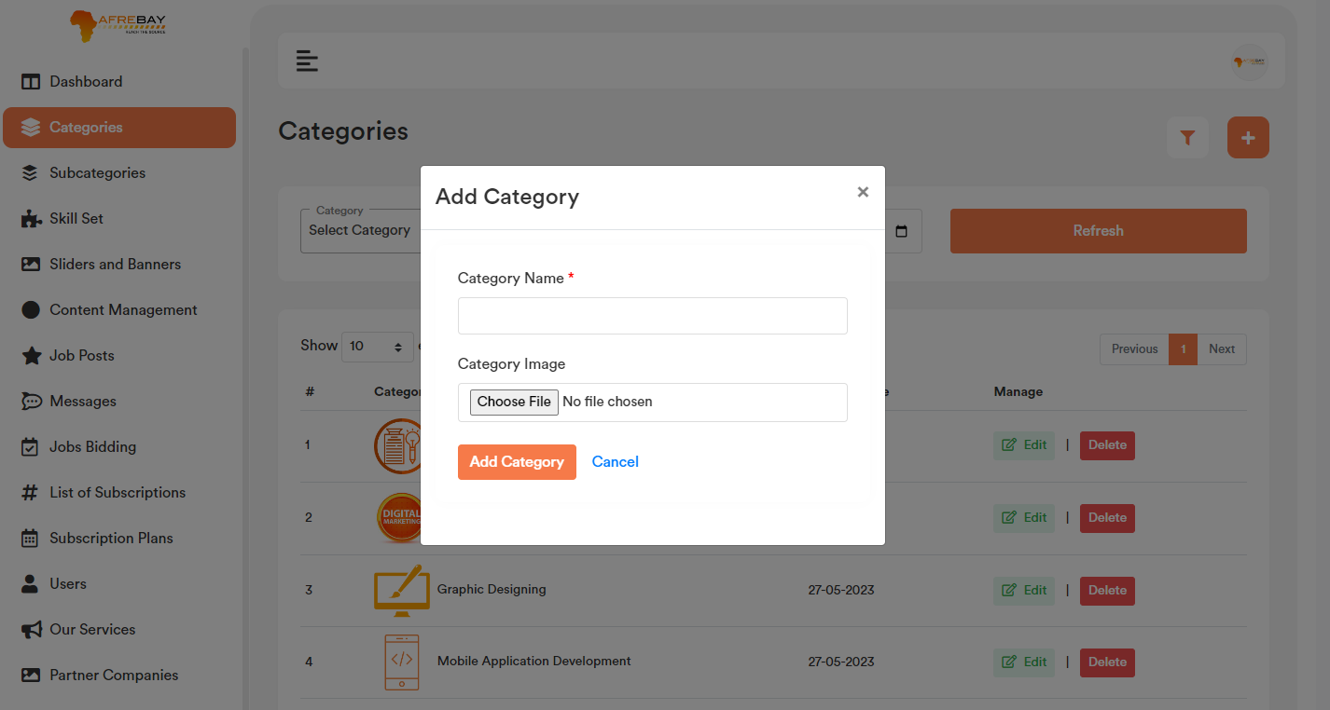

**b. Edit Category:**

Category list page for each record if user click on the “Edit” option, it will open a form containing the existing category data for that particular record. After making the change click on the “Save Changes” button. It will update the existing record with the updated data. Please check the below screenshot.

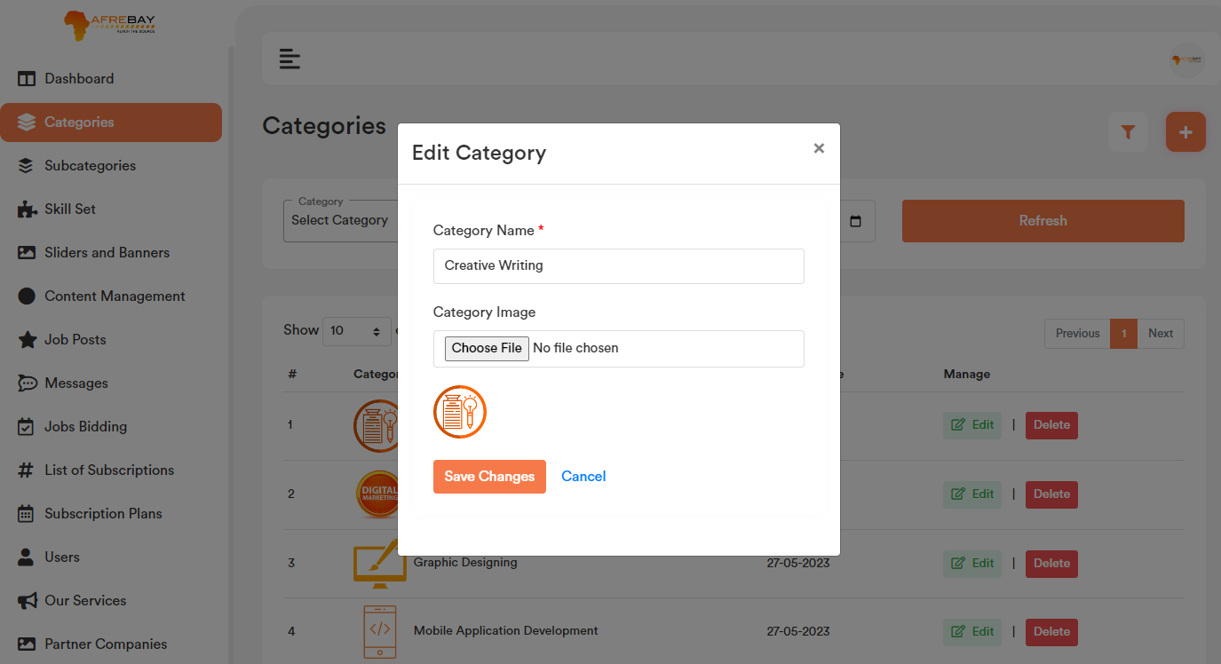

1. **Delete Record:**

If user click on the “Delete” Button, user will get a confirmation popup. Once confirm it will delete the related category data. If any job post is there related to any category and admin wants to delete that category, it will show an alert “**Job post is there related to this category. Please delete the job first to delete this category**”. After delete the post job user will only be able to delete the category.

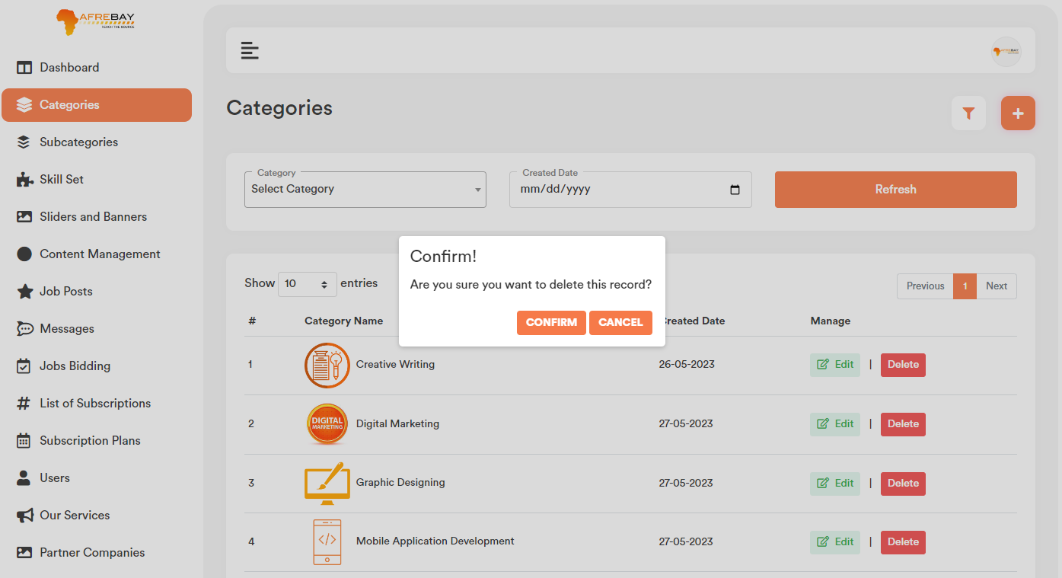

1. **Category Filter:** Based on the added category and created date admin will be able to filter any category from the category list.

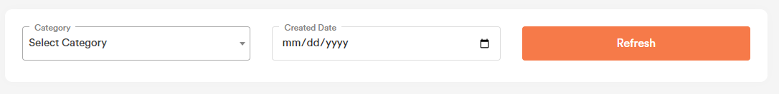

1. **Category Search:** User can search any record by typing text on the search textbox.



1. **Sub Category:**

Sub Category data will show in the website frontend, once vendor will try to add a job post. By default, sub category data will be blank in the frontend. Once vendor select any category then only sub category data will show based on the category section.

1. **Add Sub Category:**

Sub Category list page top right corner click on the “+” icon. User will get a form to add new Sub Category. Please select the category name from the dropdown first, based on the category selection user can add new sub category. Please check the below screenshot.

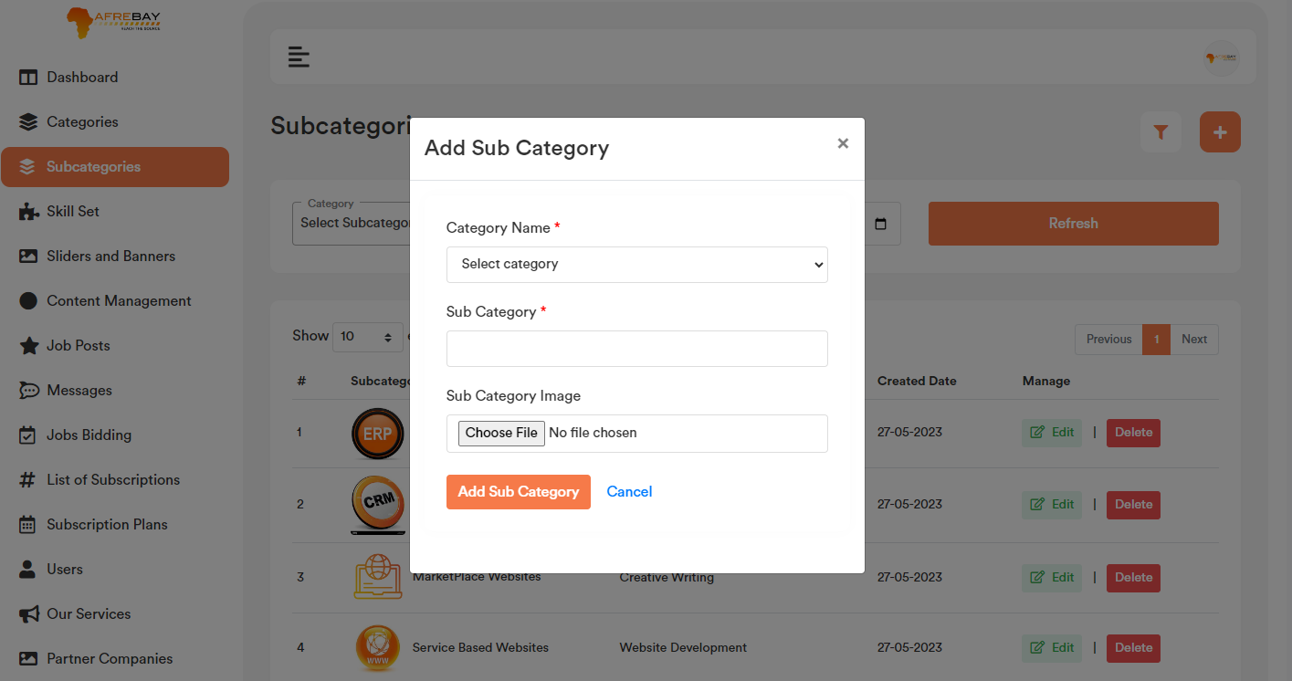

1. **Edit Sub Category:**

Sub Category list page for each record if user click on the “Edit” option, it will open a form containing the existing sub category data for that particular record. After making the change click on the “Save Changes” button. It will update the existing record will the updated data. Please check the below screenshot.

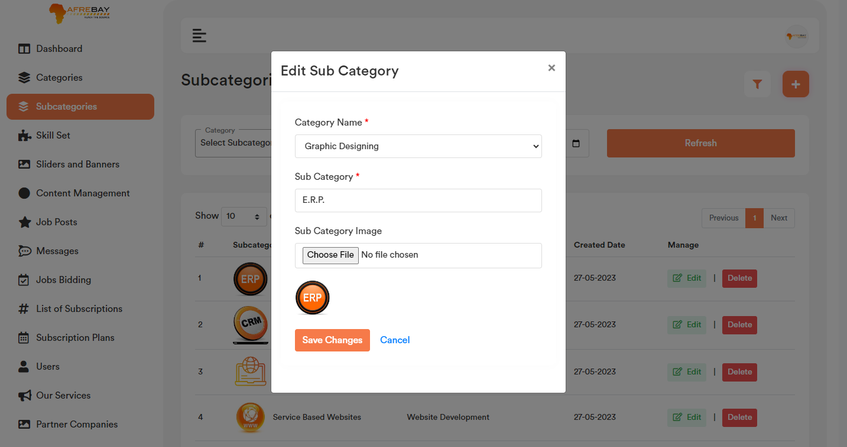

1. **Delete Sub Category:**

If user click on the “Delete” Button, user will get a confirmation popup. Once confirm it will delete the related sub category data.

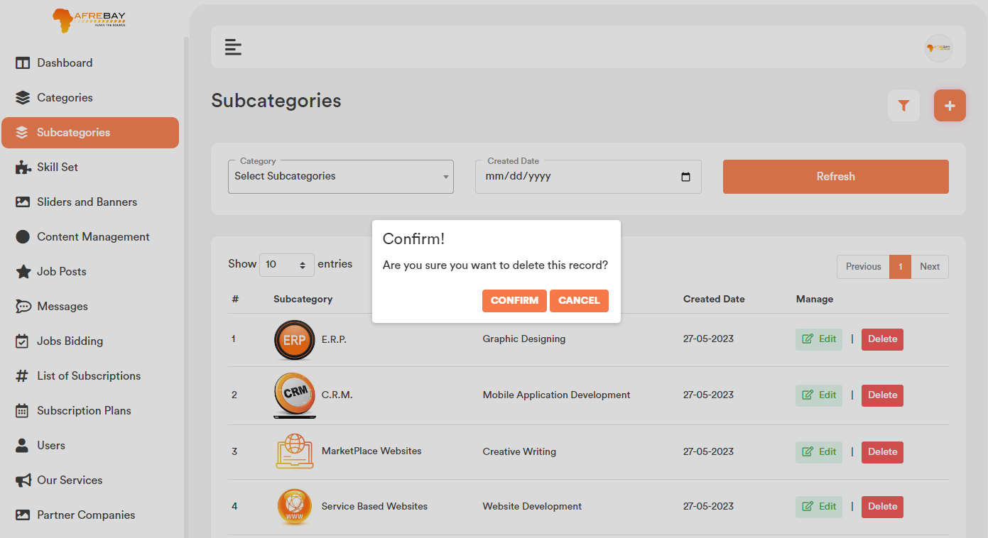

1. **Sub Category Filter:**

Based on the added sub category and created date admin will be able to filter any sub category from the category list.

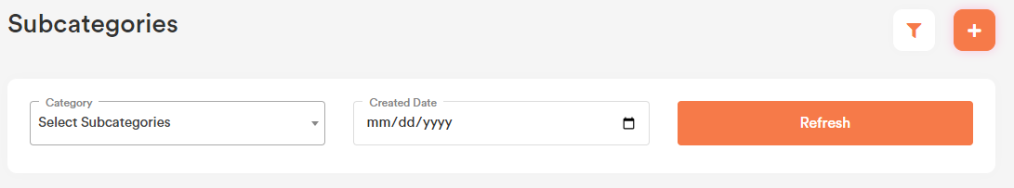

1. **Sub Category Search:**

User can search any record by typing text on the search textbox.



1. **Skill Set:**

Vendor will be able to add skills from post job page. Those skills will show in the admin skill set list.

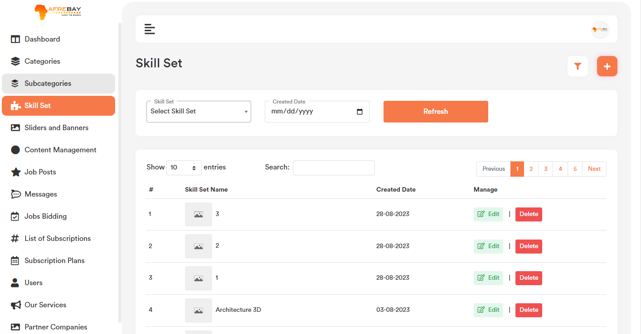

1. **Add Skill Set:**

Skill Set list page top right corner click on the “+” icon. User will get a form to add new skill set. Please check the below screenshot.



1. **Edit Skill Set:**

Skill Set list page for each record if user click on the “Edit” option, it will open a form containing the existing Skill Set name data for that particular record. After making the change click on the “Save Changes” button. It will update the existing record will the updated data. Please check the below screenshot.



1. **Delete Skill Set:**

If user click on the “Delete” Button, user will get a confirmation popup. Once confirm it will delete the related sub category data.

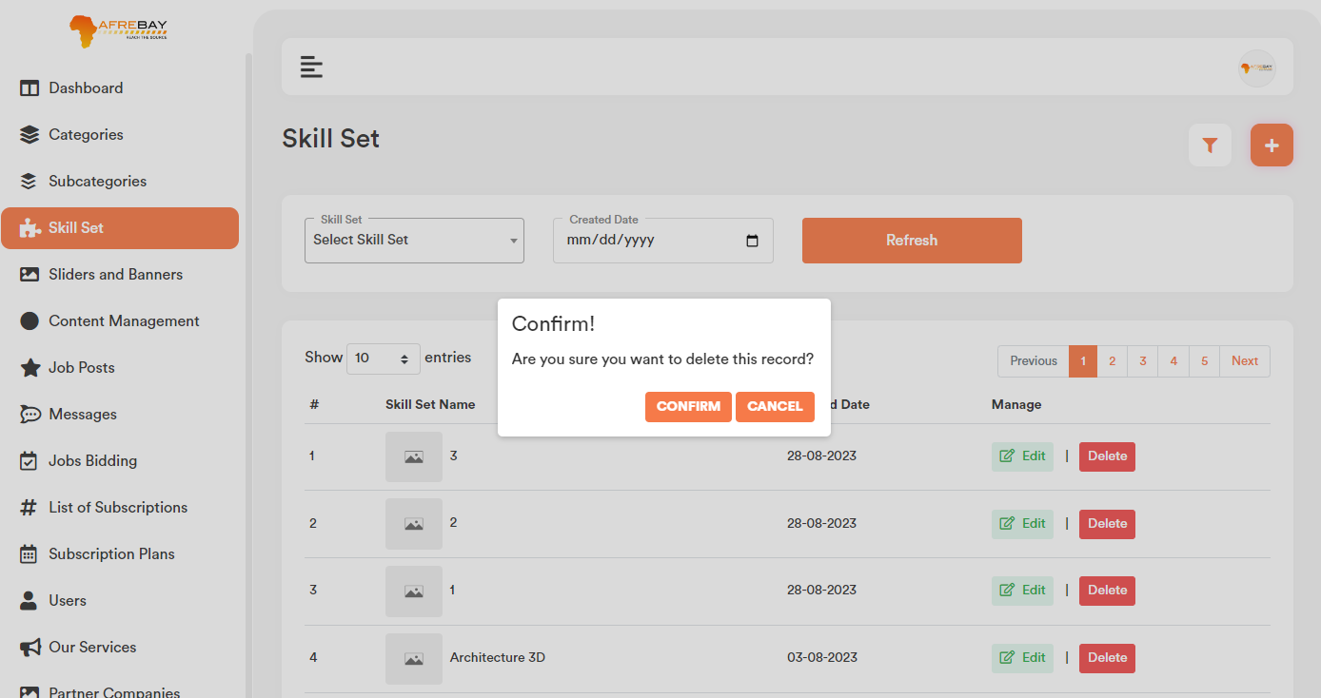

1. **Skill Set Filter:**

Based on the added skill sets and created date admin will be able to filter any skill sets from the skill sets list.

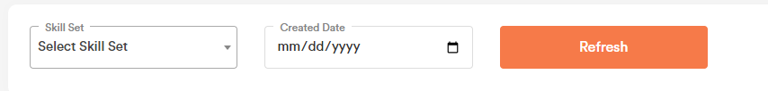

1. **Skill Set Search:** User can search any record by typing text on the search textbox.



1. **Sliders and Banners:**

All the listed banner will show in the respective frontend pages.

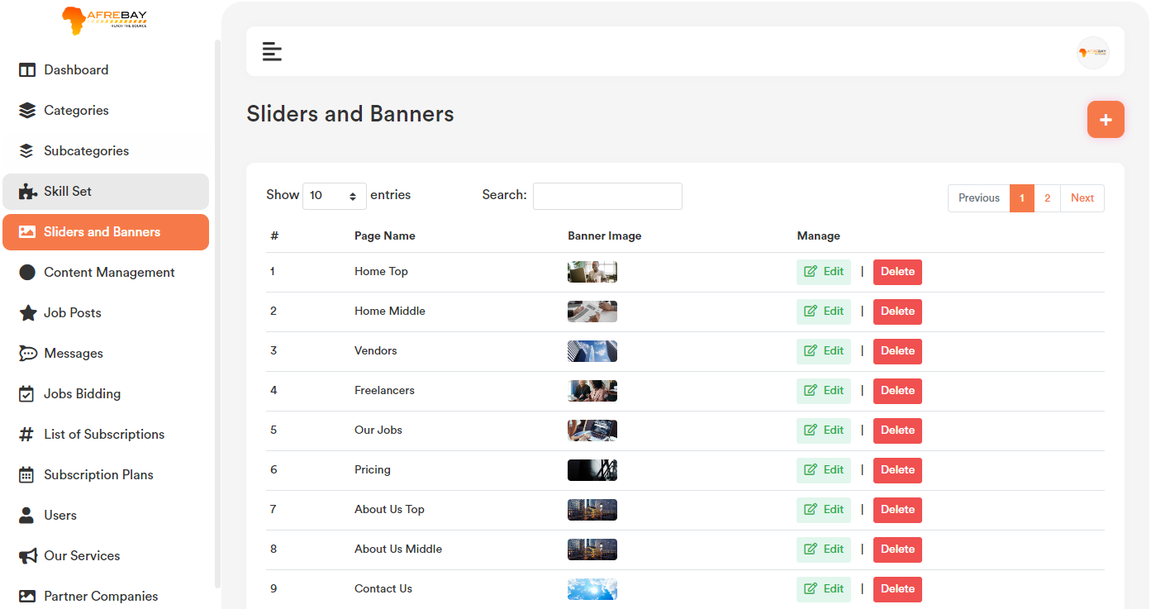

1. **Add Sliders and Banners:**

Sliders and Banners list page top right corner click on the “+” icon. User will get a form to add new banner. Please check the below screenshot.

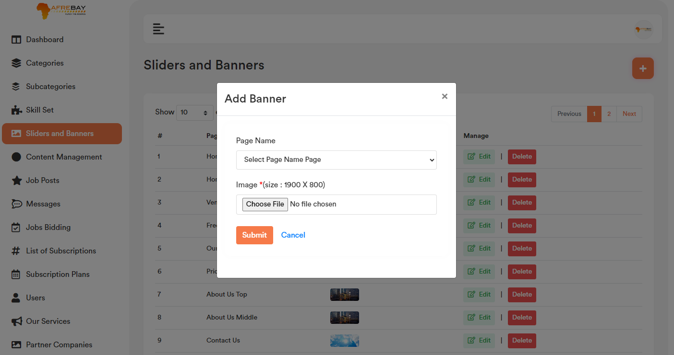

1. **Edit Sliders and Banners:**

Banner list page for each record if user click on the “Edit” option, it will open a form containing the existing banner data for that particular record. After making the change click on the “Save Changes” button. It will update the existing record will the updated data. Please check the below screenshot.

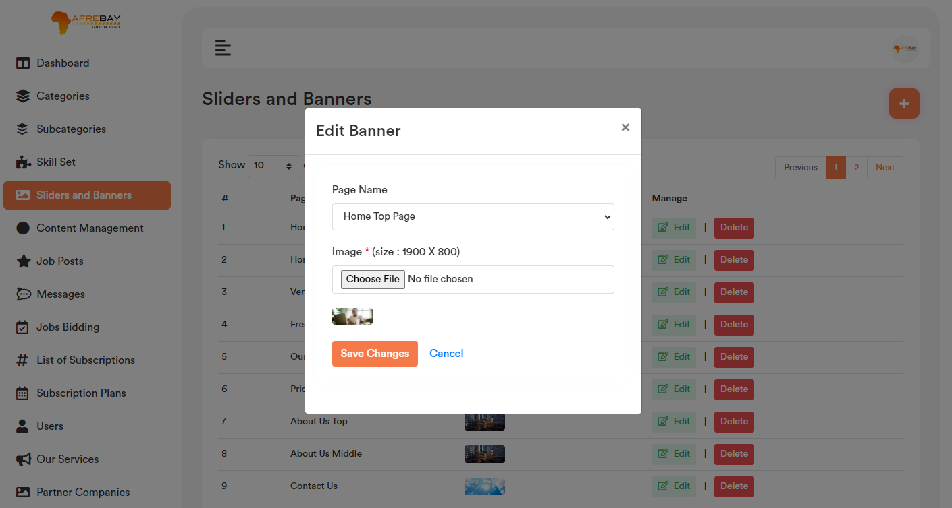

1. **Delete Sliders and Banners:**

If user click on the “Delete” Button, user will get a confirmation popup. Once confirm it will delete the related banner data.

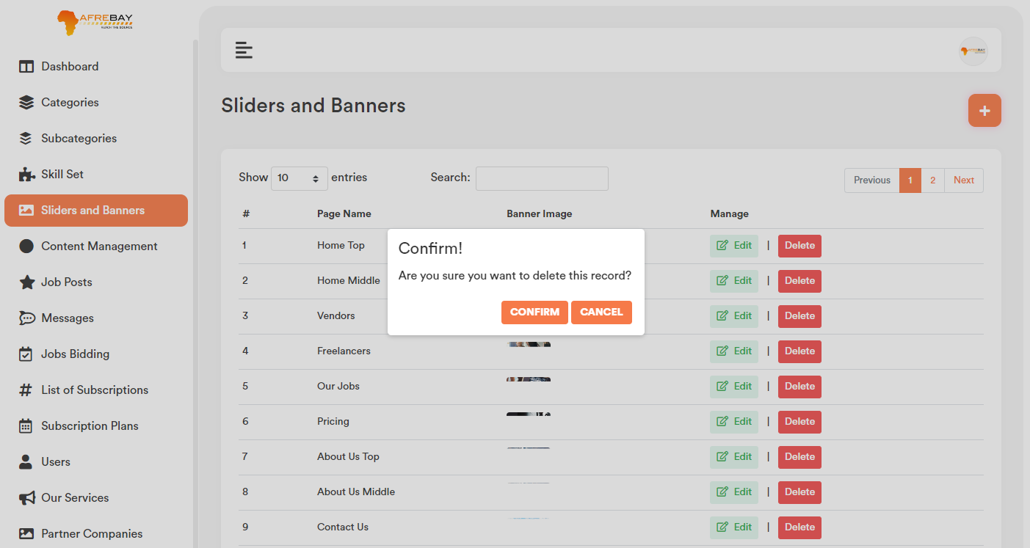

1. **Sliders and Banners Search:**

User can search any record by typing text on the search textbox.



1. **Content Management:**

Admin will be able to update or change ‘About Us’, ‘Privacy Policy’, ‘Terms and Conditions’ page content.

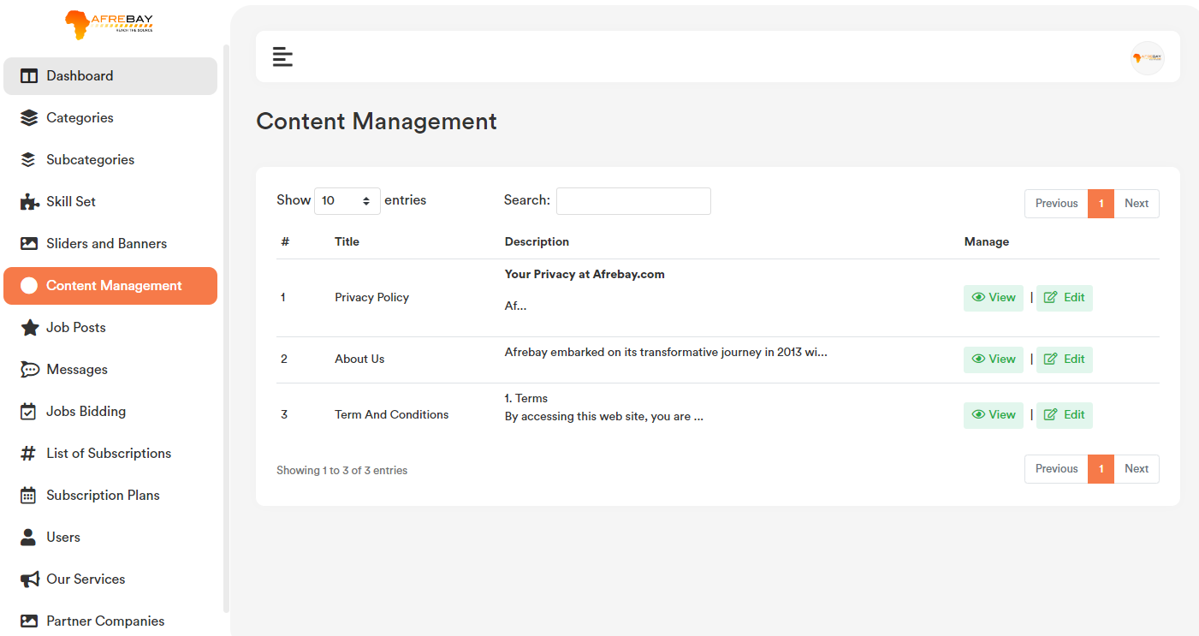

1. **Edit Content Management:**

Content Management list page for each record if user click on the “Edit” option, it will open a form containing the existing data for that particular record. After making the change click on the “Save Changes” button. It will update the existing record will the updated data. Please check the below screenshot.

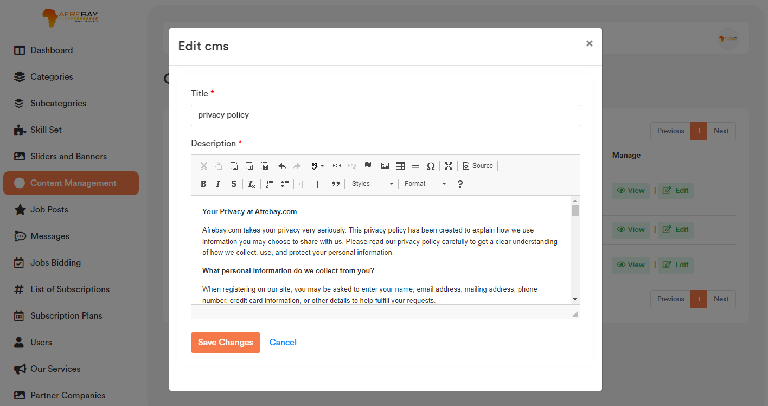

1. **View Content Management:**

Content Management list page for each record if user click on the “View” button option, it will open a modal containing the data for that particular record. Please check the below screenshot.

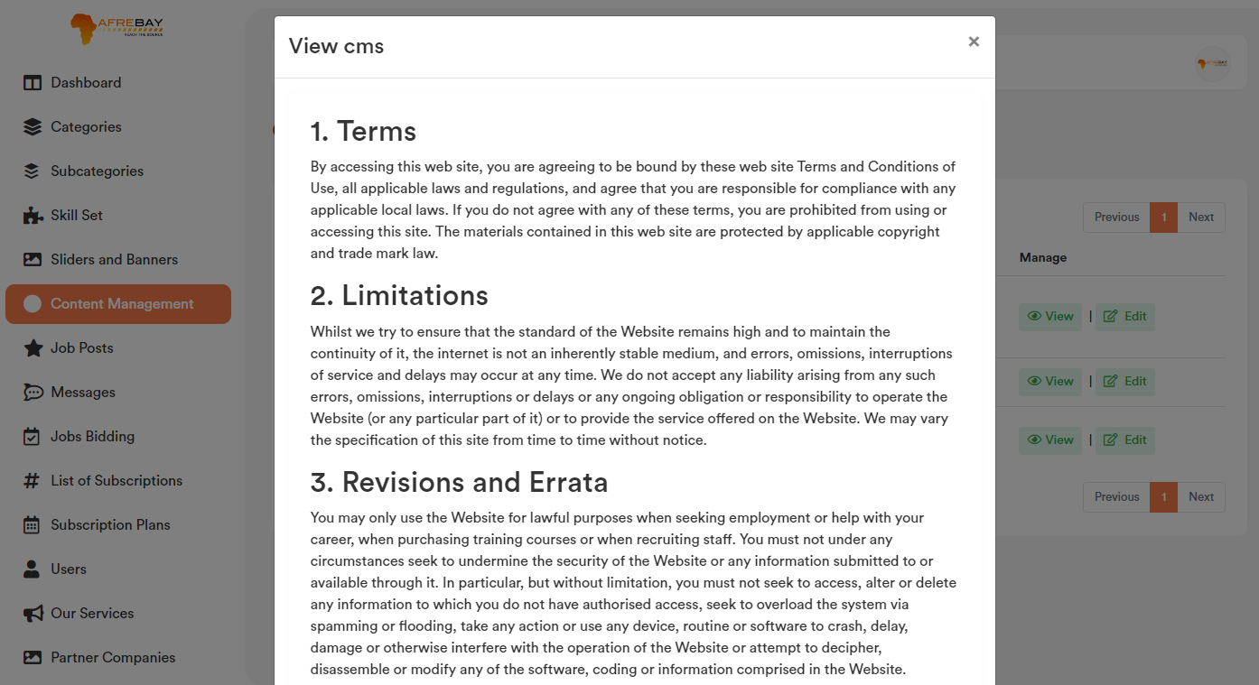

1. **Content Management Search:**

User can search any record by typing text on the search textbox.



1. **Job Posts Section:**

All job posted by vendors will listed in the job post section. Admin can edit, update, delete and also change the status of a particular job.

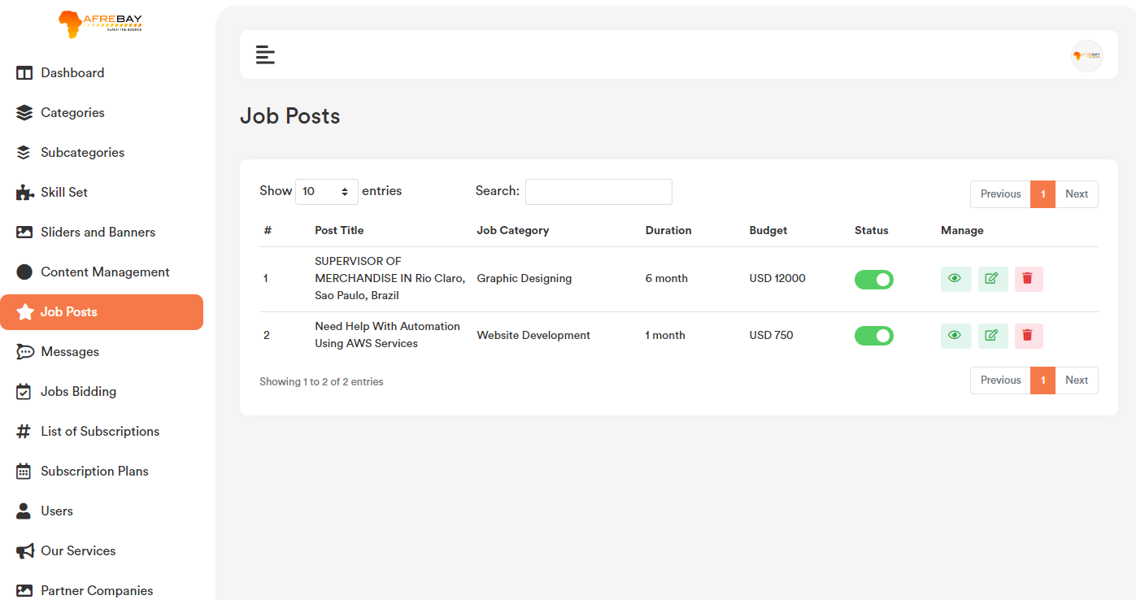

1. **Edit Job Posts:**

Job Post list page for each record if user click on the “Edit” option, it will open a form containing the existing post job data for that particular job. After making the change click on the “Save Changes” button. It will update the existing record will the updated data. Please check the below screenshot.

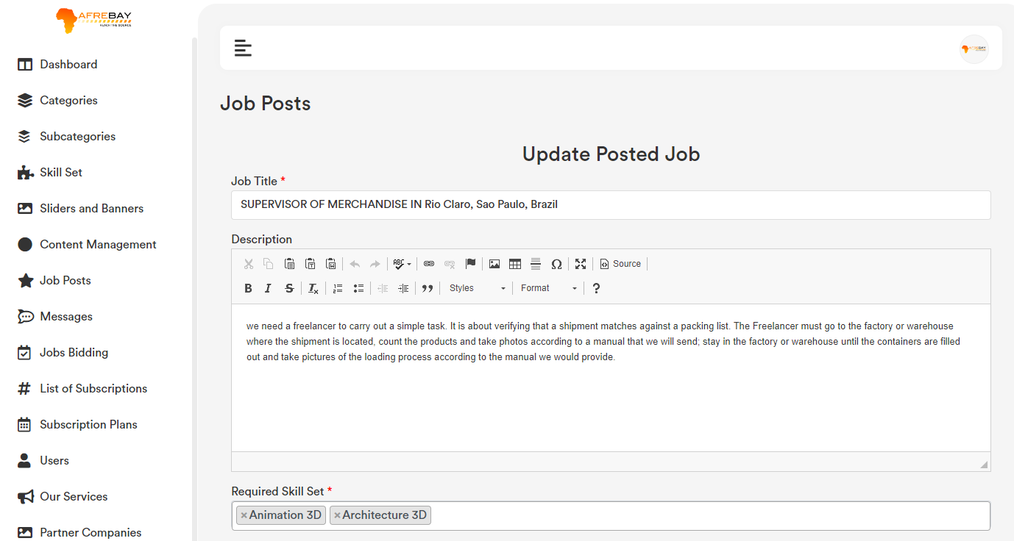

1. **View Job Posts:**

Job Post list page for each record if user click on the “View” option, it will redirect to the frontend post job details page. Please check the below screenshot.

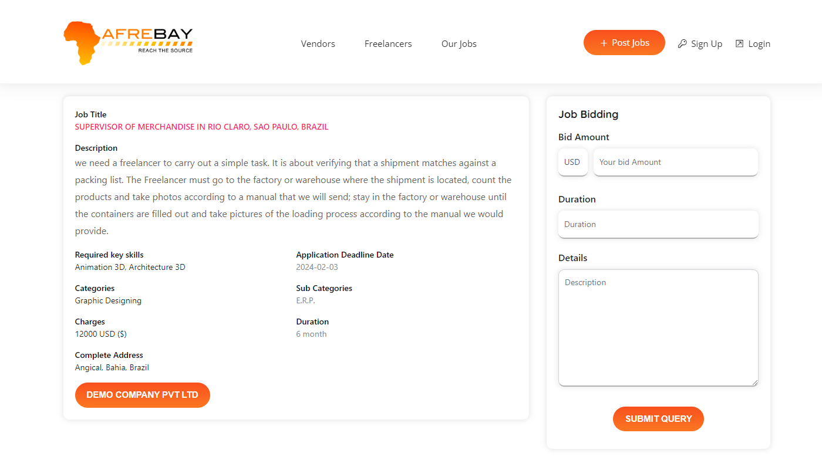

1. **Delete Job Posts:**

If user click on the “Delete” Button, user will get a confirmation popup. Once confirm it will delete the related banner data.

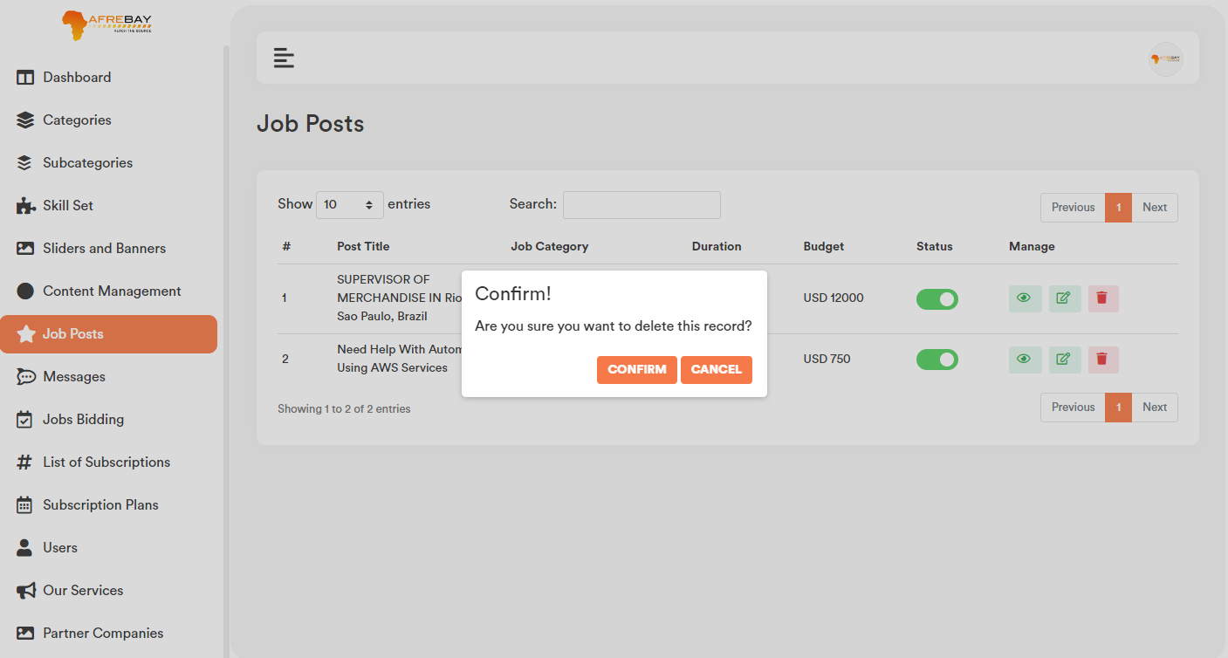

1. **Job Posts (Active/Inactive):**

Once user click on the toggle button user will get a confirmation popup to active/inactive the job posts.

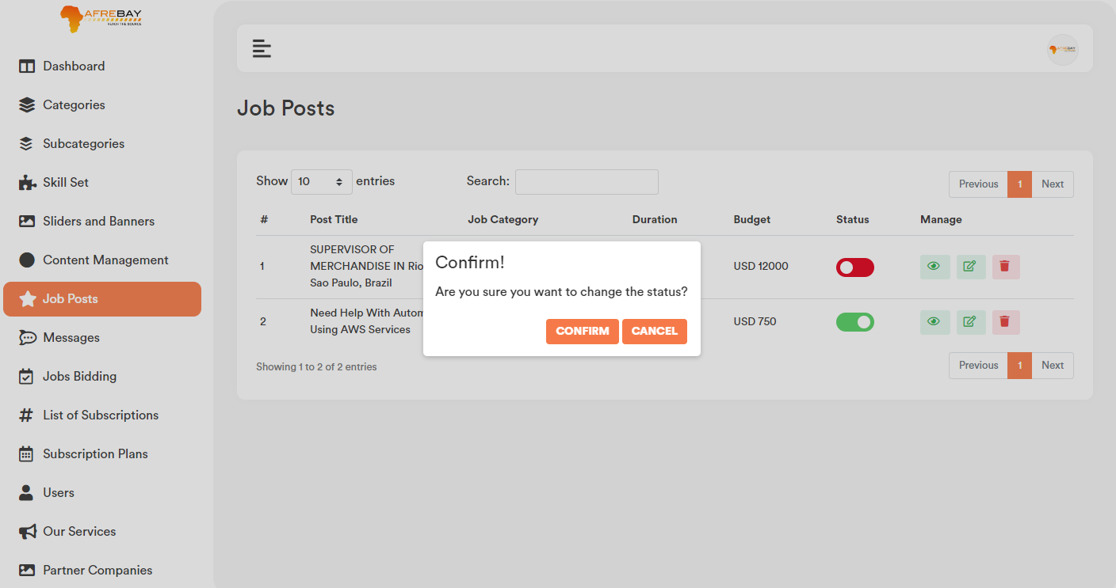

1. **Content Job Posts:**

User can search any record by typing text on the search textbox.



1. **Messages:**

Jobs related messages will be listed in the message section. Once click on the “view chat” button, it will show the details message for that particular post.

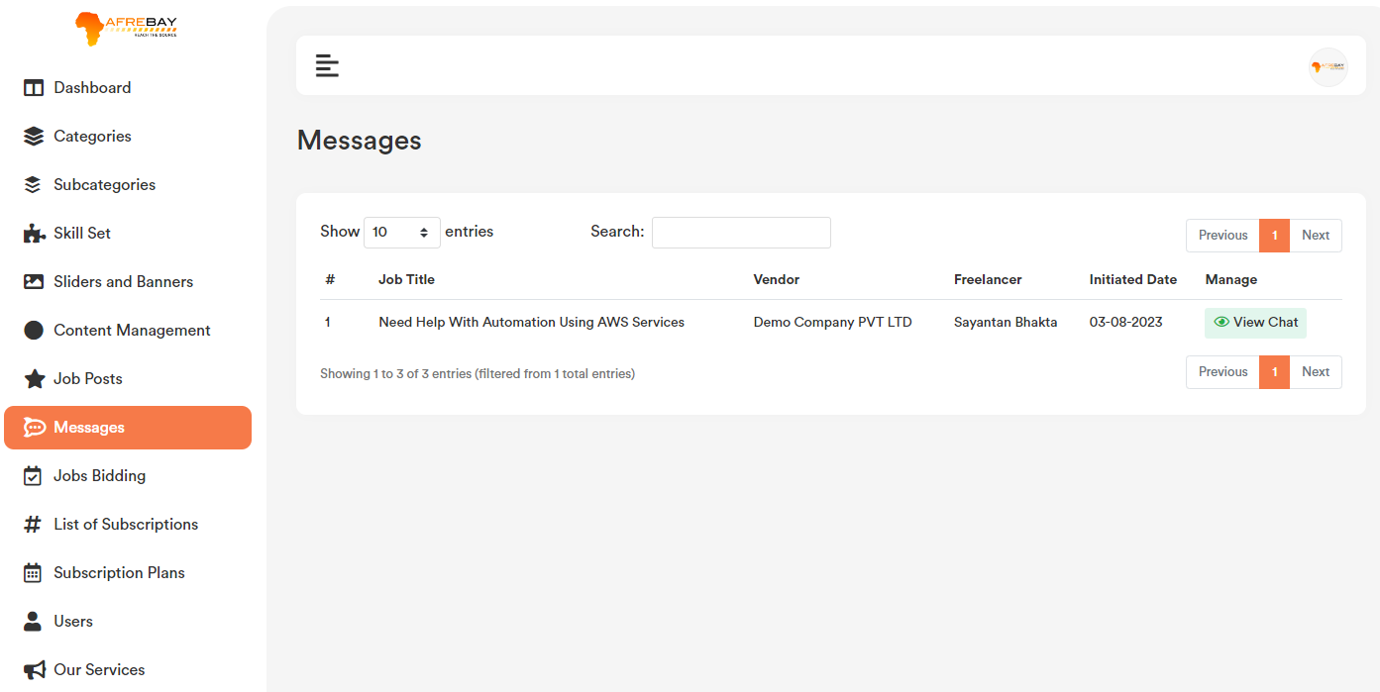

1. **View Messages:**

Message list page for each record if user click on the “View Chat” option, it will it will show the details message for that particular post. Please check the below screenshot.

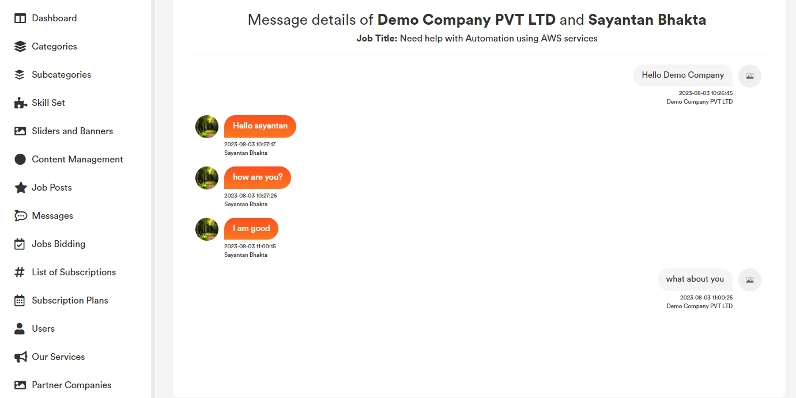

1. **Search Messages:**

User can search any record by typing text on the search textbox.



1. **Job Bidding:**

All Job Bid by freelancer for all job post will be listed in the job bidding section. Admin can only view job details by clicking on the “Eye Icon”.

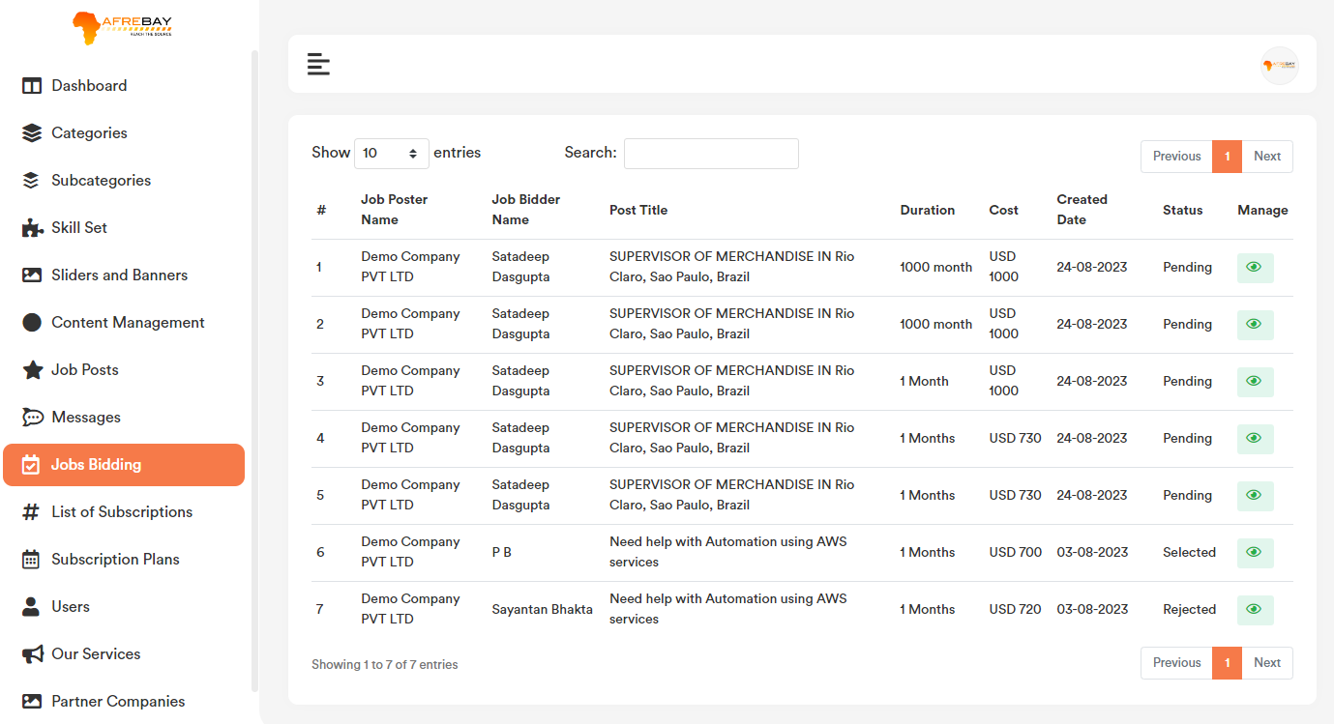

1. **View Job Bidding:**

Job Bidding list page for each record if user click on the “Eye icon” button option, it will redirect to the frontend job details page. Please check the below screenshot.



1. **Job Bidding Search:**

User can search any record by typing text on the search textbox.



1. **List of Subscriptions:**

Subscribe list for venders and freelancer will be listed in this section. Admin and only view and download invoice of the payment for any users.



1. **View Users Subscription:**

Users Subscription list page for each record if user click on the “Eye Icon” button option, it will open a modal containing few details (Like **Transaction ID**, **Current subscription Status** and **Invoice Download** option.) data for that particular user. Please check the below screenshot.

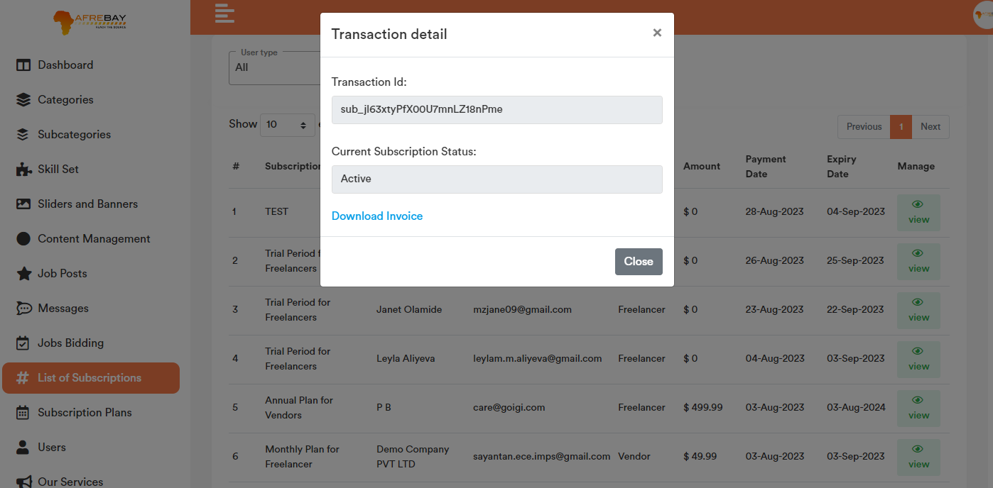

1. **Users Subscription Filter:**

Based on the user type admin will be able to filter user subscription details from the subscription list.

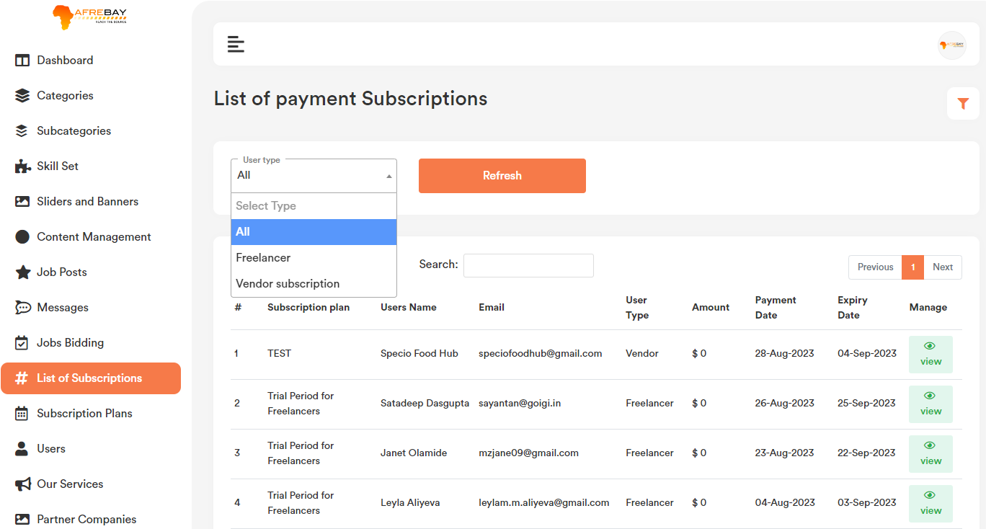

1. **Users Subscription Search:**

User can search any record by typing text on the search textbox.



1. **Subscription Plan:**

Subscription plan for both freelancer and vendor plan and also for Global and Nigeria subscription plan will be listed here.

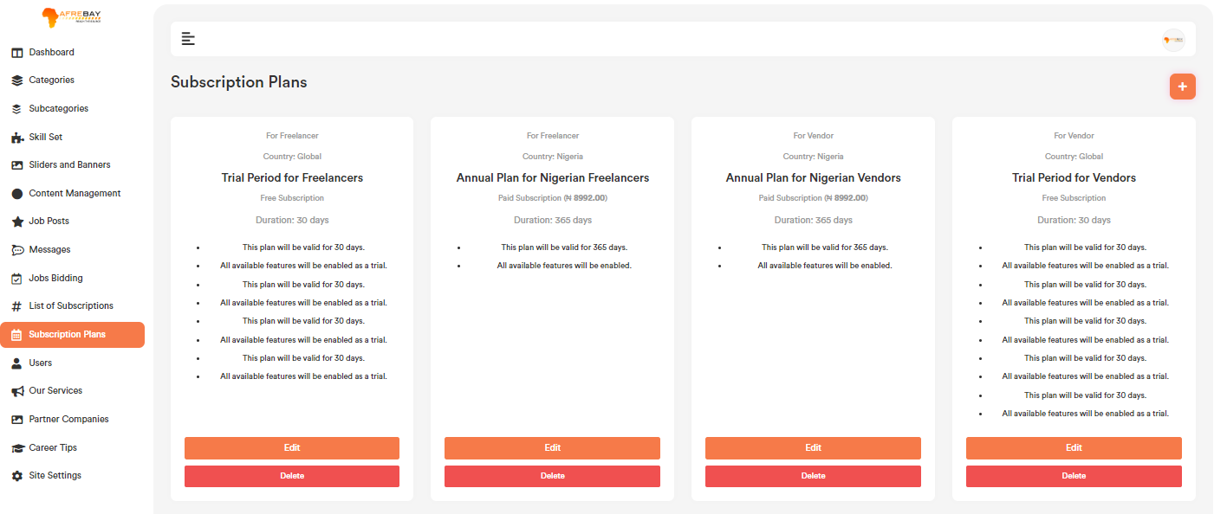

1. **Add Subscription Plan:**

Subscriptionlist page top right corner click on the “+” icon. User will get a form to add new subscription plan. Please check the below screenshot.

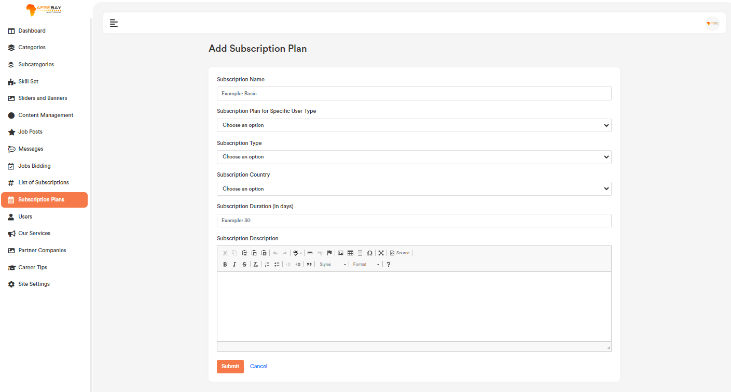

* For “Free” plan and both the country, price is set as ‘0’.

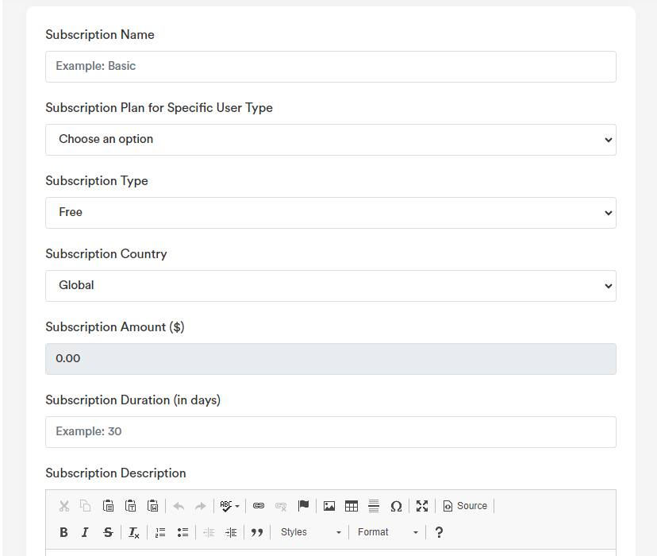

* For “Paid” plan country “Global” user can set price, also user need to add “Stripe product key, price key”

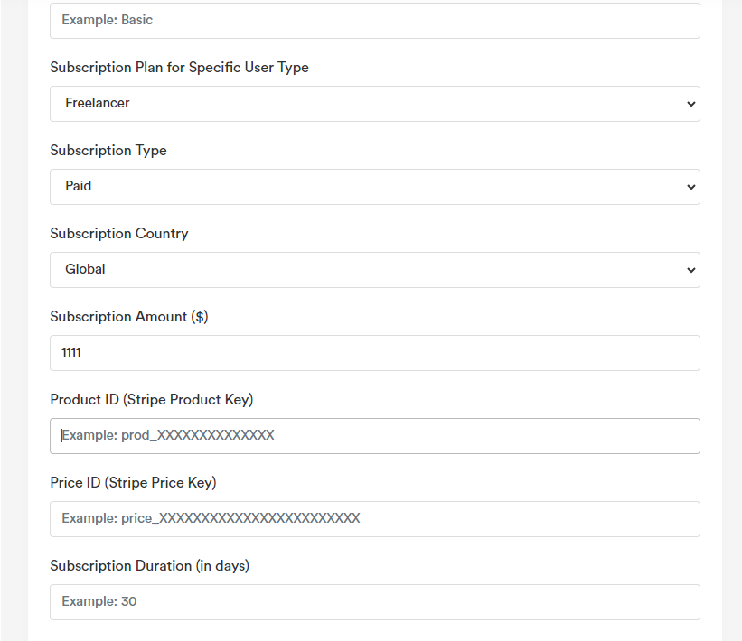

* For “Paid” plan country “Nigeria” user can set price, also user need to add “Pay Stack Plan Code”.

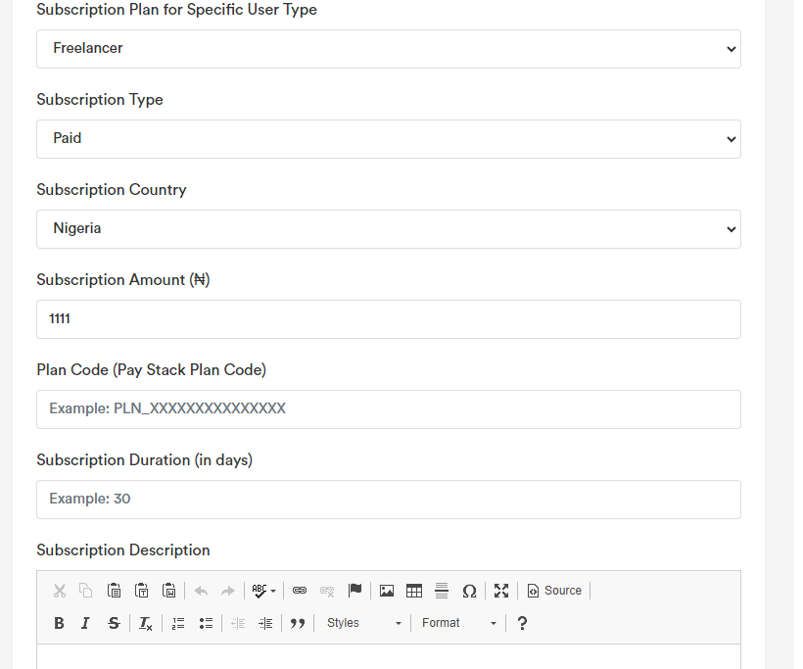

**b. Edit Subscription Plan:**

Subscriptionlist page for each record if user click on the “Edit” option, it will open a form containing the existing data for that particular record. After making the change click on the “Save Changes” button. It will update the existing record will the updated data. Please check the below screenshot.

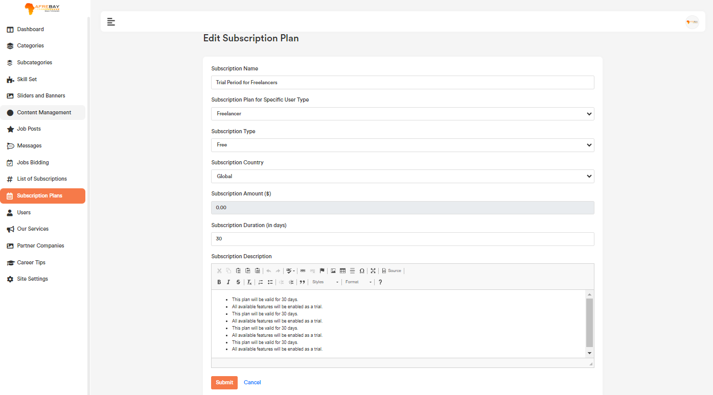

1. **Delete Subscription Plan:**

If user click on the “Delete” Button, user will get a confirmation popup. Once confirm it will delete the related data.

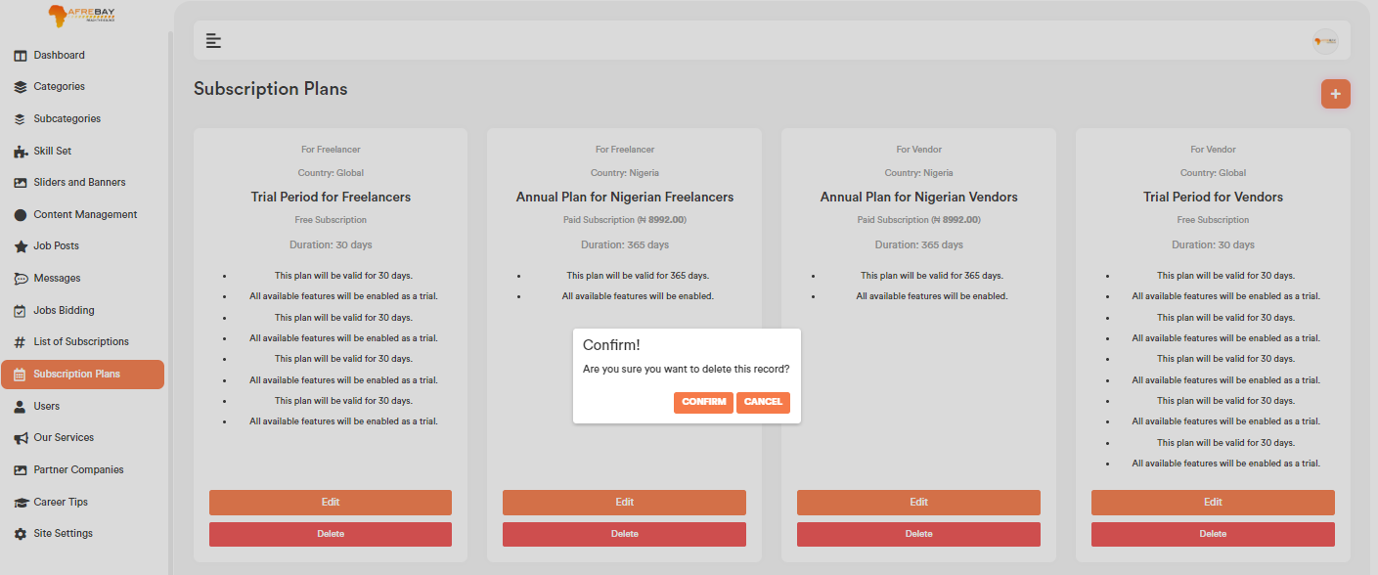

1. **Users:**

All the registered users will be listed in the uses section. Admin can verify user, change status, update users details and delete users.

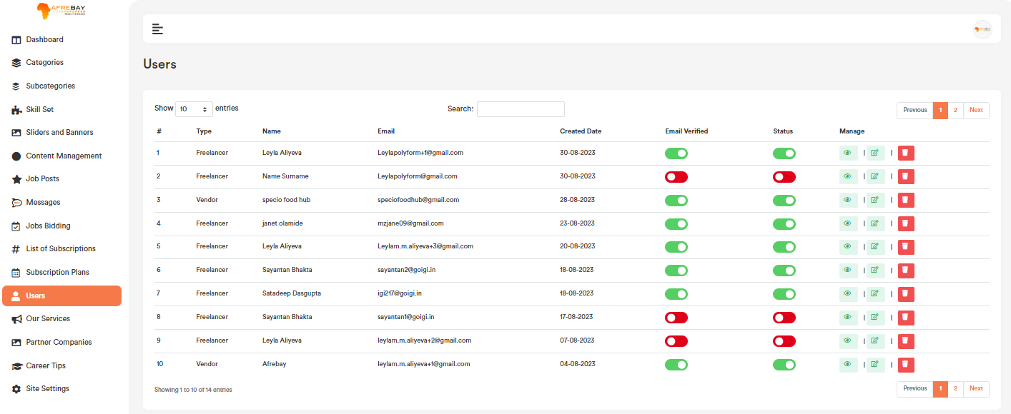

1. **View Users:**

Users list page top right corner click on the “Eye Icon” icon, it will redirect to the particular users details page in the website frontend. Please check the below screenshot.

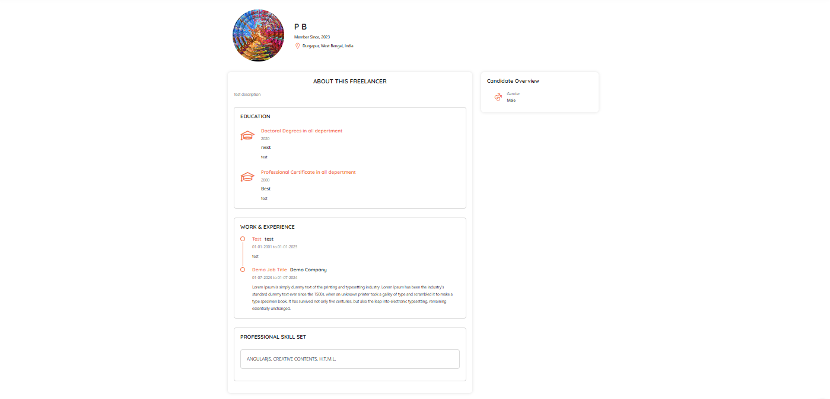

**b. Edit Users:**

Users list page for each record if user click on the “Edit Icon” button option, it will open a form containing the existing user data for that particular user. After making the change click on the “Save Changes” button. It will update the existing record will the updated data. Please check the below screenshot.

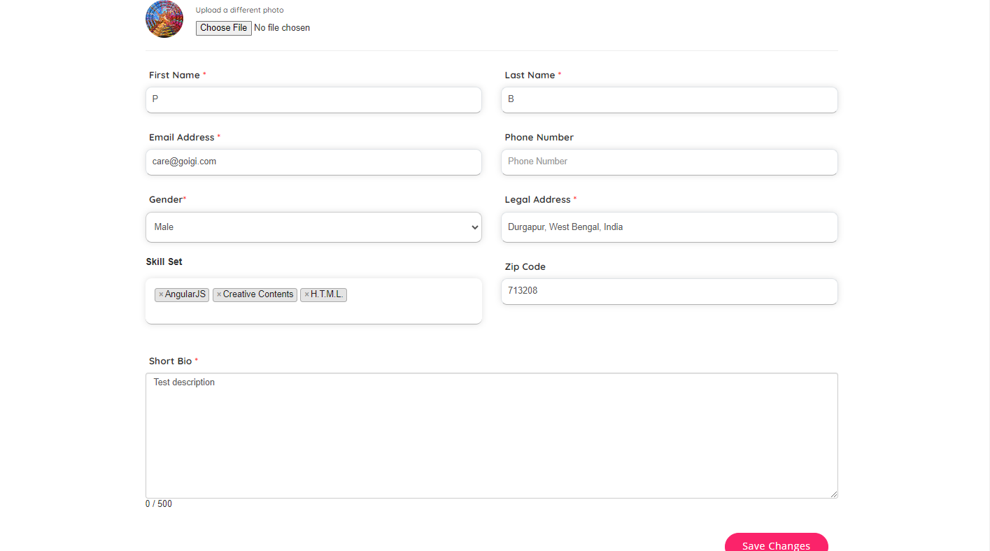

1. **Email Verification:**

For those users, who is unable to verify himself/herself by clicking on the email verification link, admin can verify them by toggle on the “Email Verified” column.

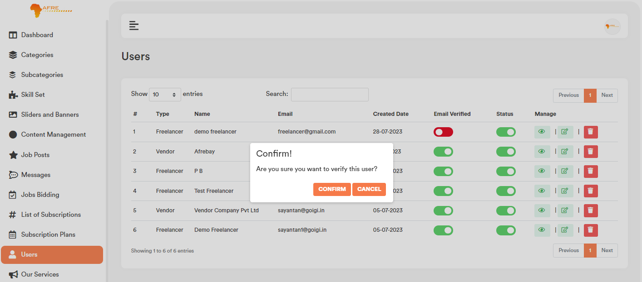

1. **Status (Active/Inactive):**

Admin Can active and inactive userby toggle on the “Status” column.

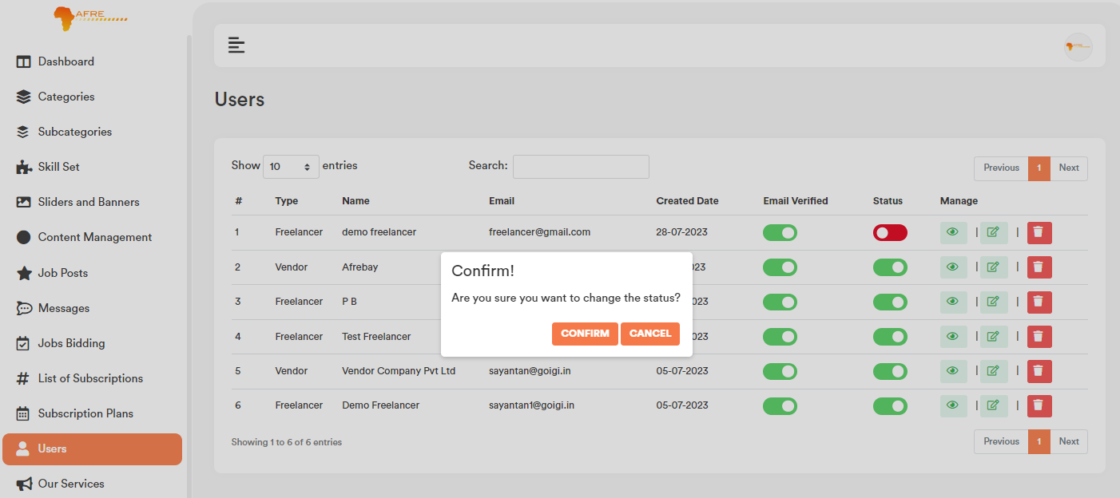

1. **Delete Record:**

If user click on the “Delete” Button, admin will get a confirmation popup. Once confirm it will delete the related data.

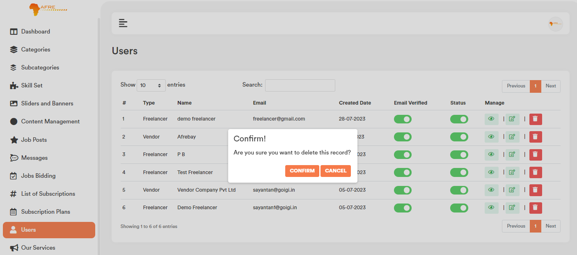

1. **User Search:**

User can search any record by typing text on the search textbox.



1. **Our Services:**

All the uploaded data will be visible on the website homepage our service section.

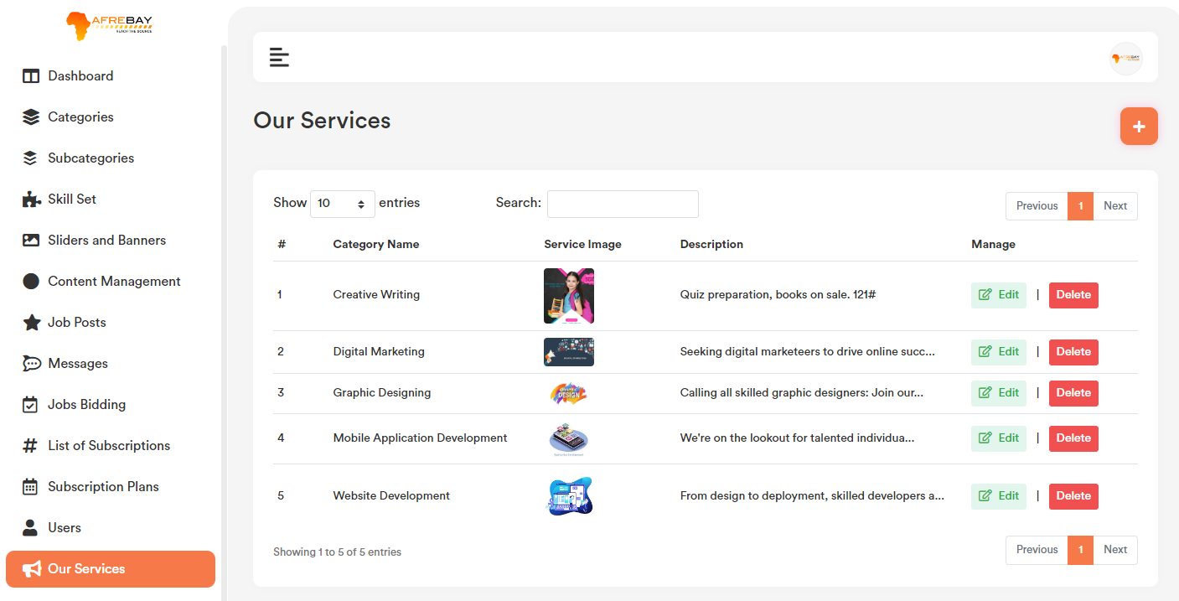

1. **Add Our Services:**

Service list page top right corner click on the “+” icon. User will get a form to add new Service. Please check the below screenshot.

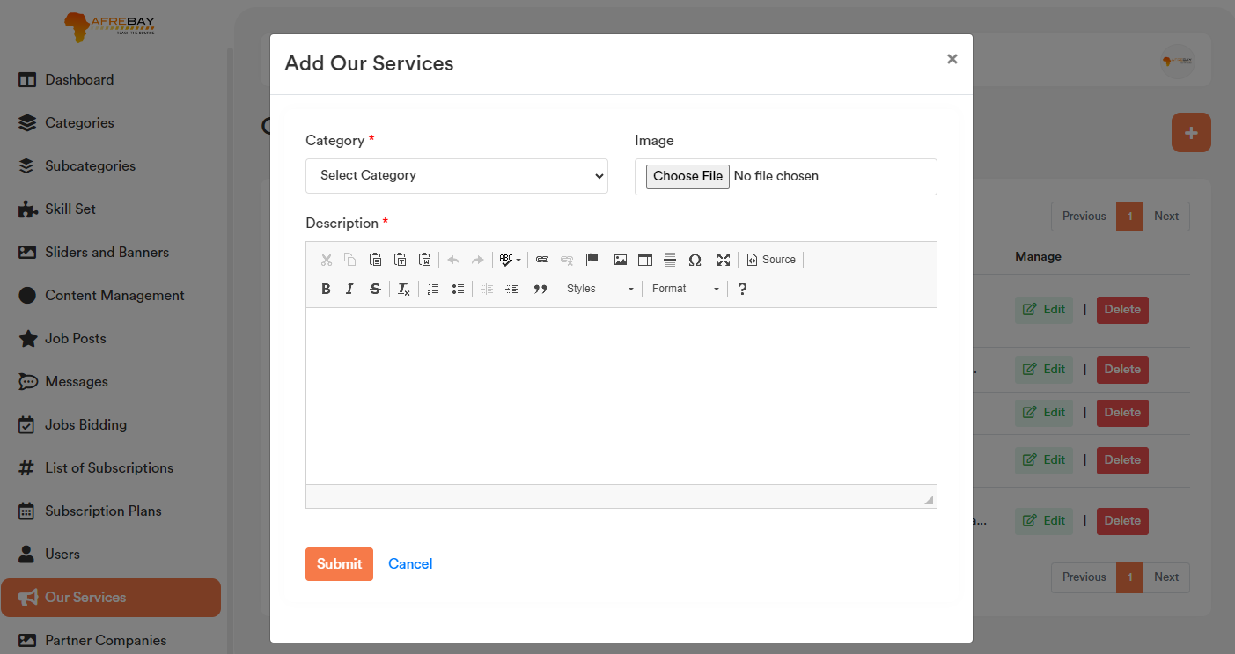

**b. Edit our Services:**

Service list page for each record if user click on the “Edit” option, it will open a form containing the existing category data for that particular record. After making the change click on the “Save Changes” button. It will update the existing record will the updated data. Please check the below screenshot.

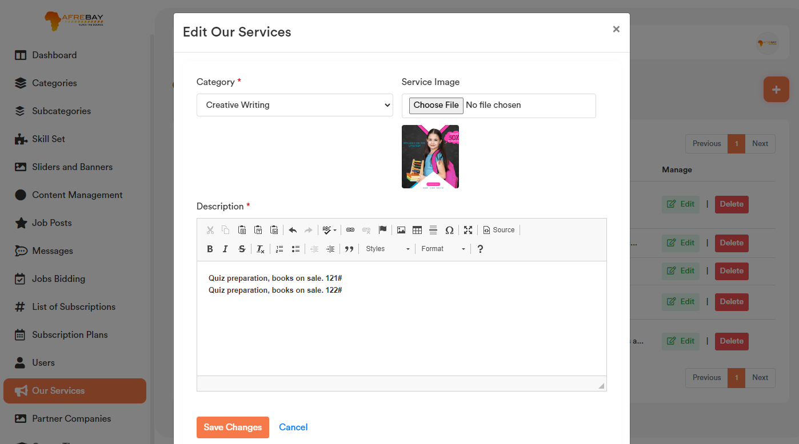

1. **Delete Our Service:**

If user click on the “Delete” Button, admin will get a confirmation popup. Once confirm it will delete the related data.

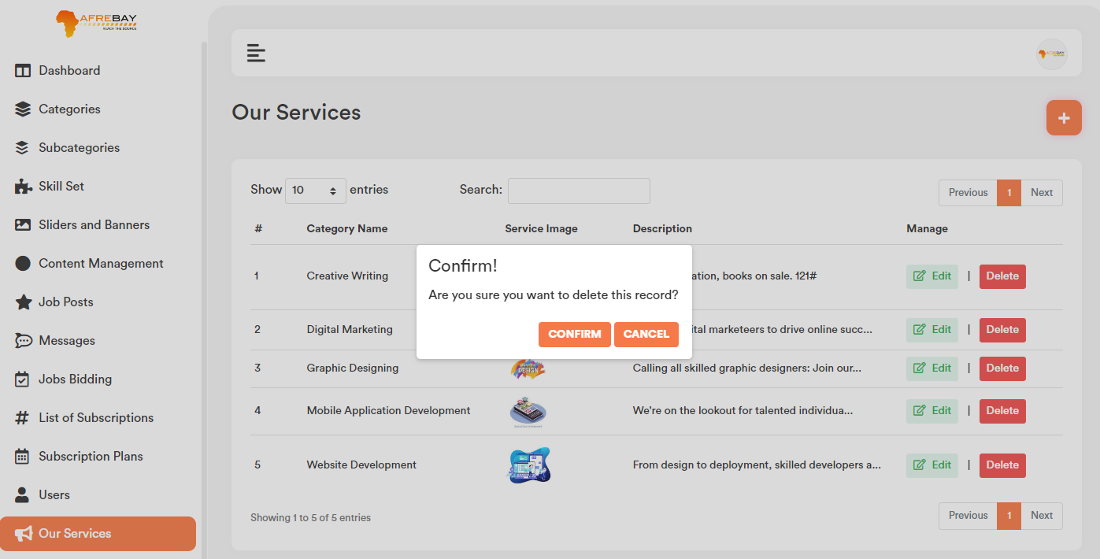

1. **Our Services Search:** User can search any record by typing text on the search textbox.

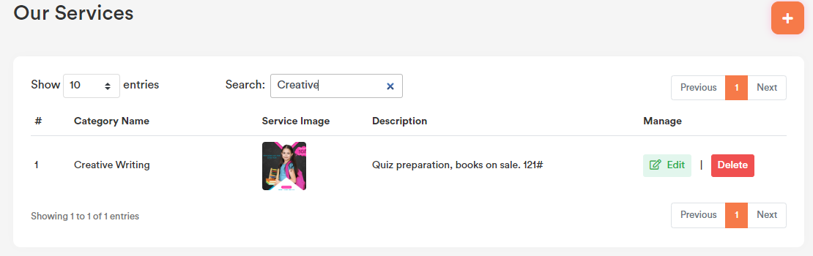

1. **Partner Companies:**

All the uploaded data will be visible on the website homepage partner company section.

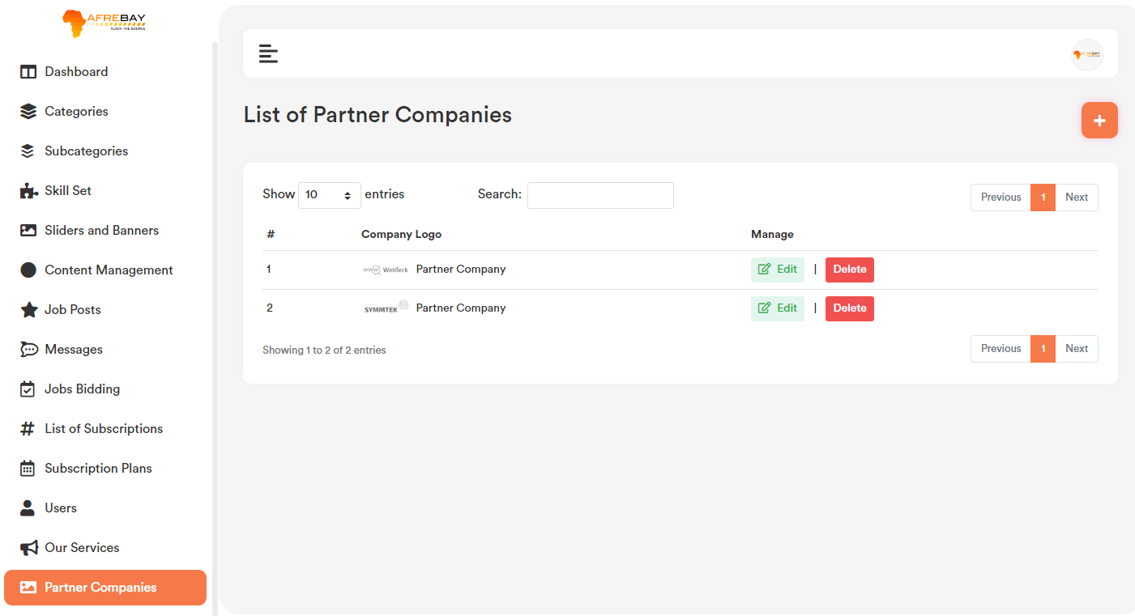

1. **Add Partner Companies:**

Partner companies list page top right corner click on the “+” icon. User will get a form to add new partner companies. Please check the below screenshot.

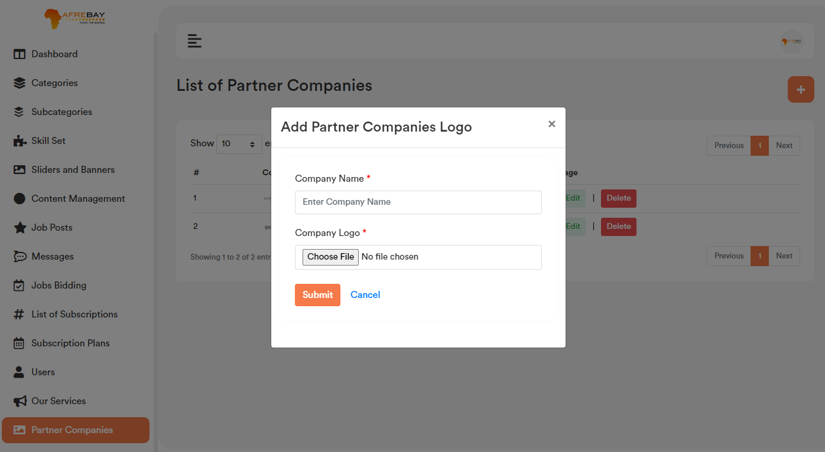

1. **Edit Partner Companies:**

Partner companies list page for each record if user click on the “Edit” option, it will open a form containing the existing data for that particular record. After making the change click on the “Save Changes” button. It will update the existing record will the updated data. Please check the below screenshot.

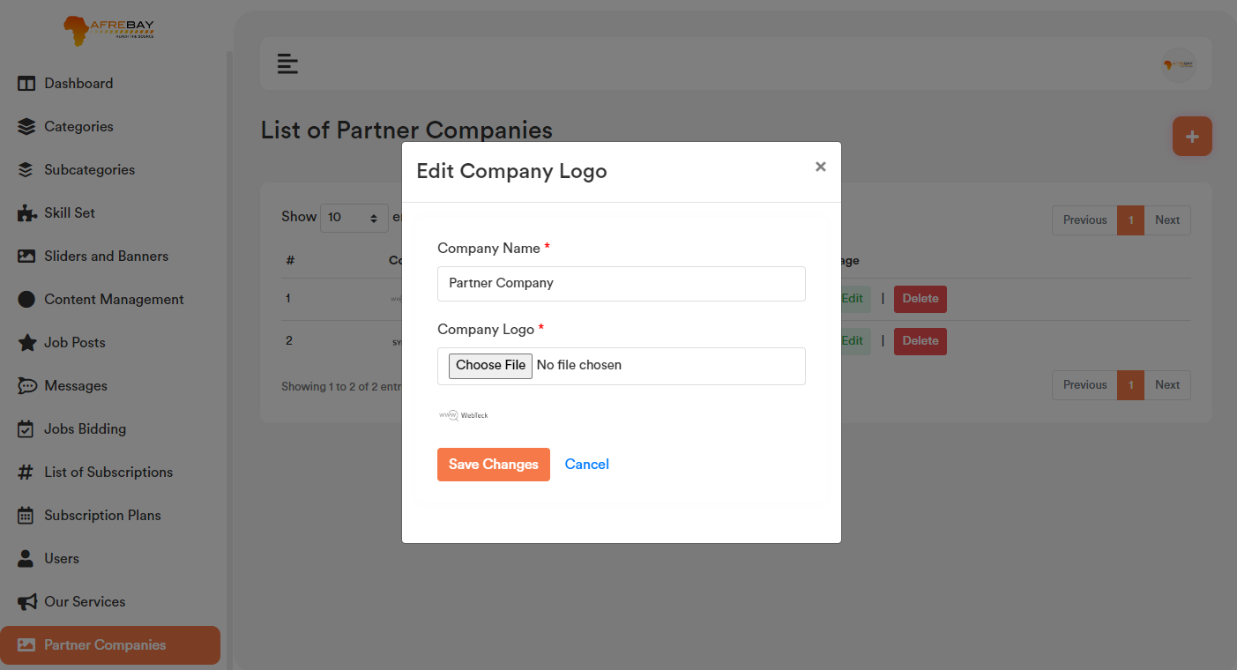

1. **Delete Partner Companies:**

If user click on the “Delete” Button, admin will get a confirmation popup. Once confirm it will delete the related data.

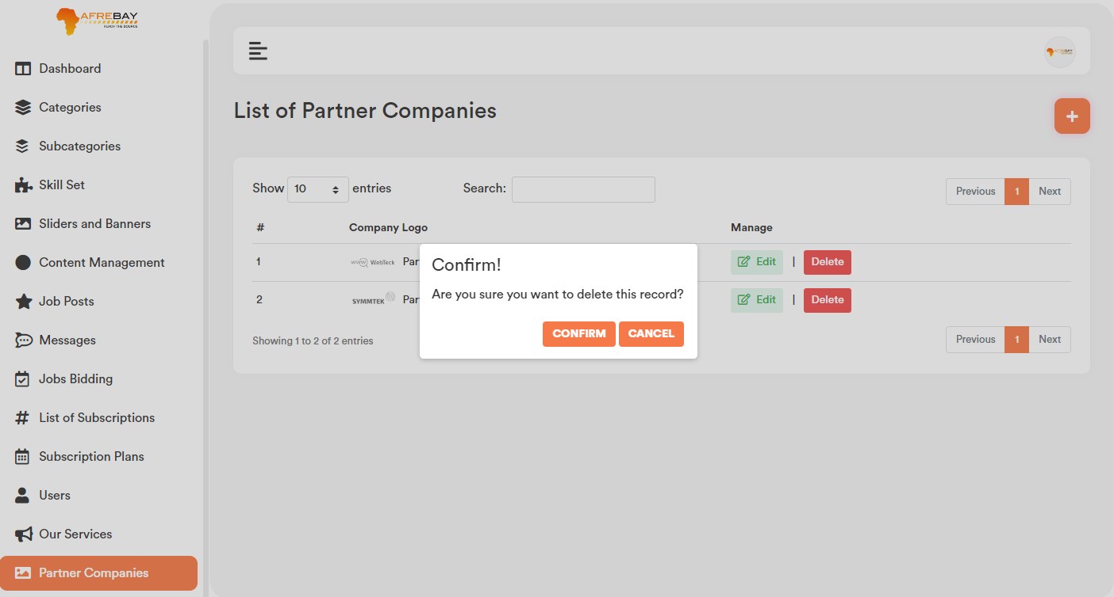

1. **Search Partner Companies:** User can search any record by typing text on the search textbox.

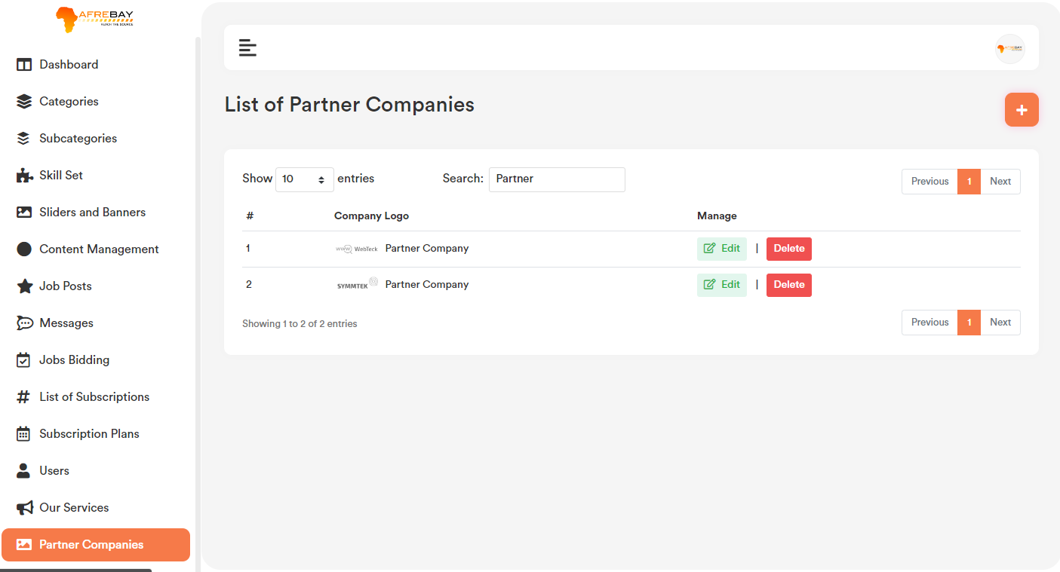

1. **Career Tips:**

All the uploaded data will be visible on the website homepage career tips section.

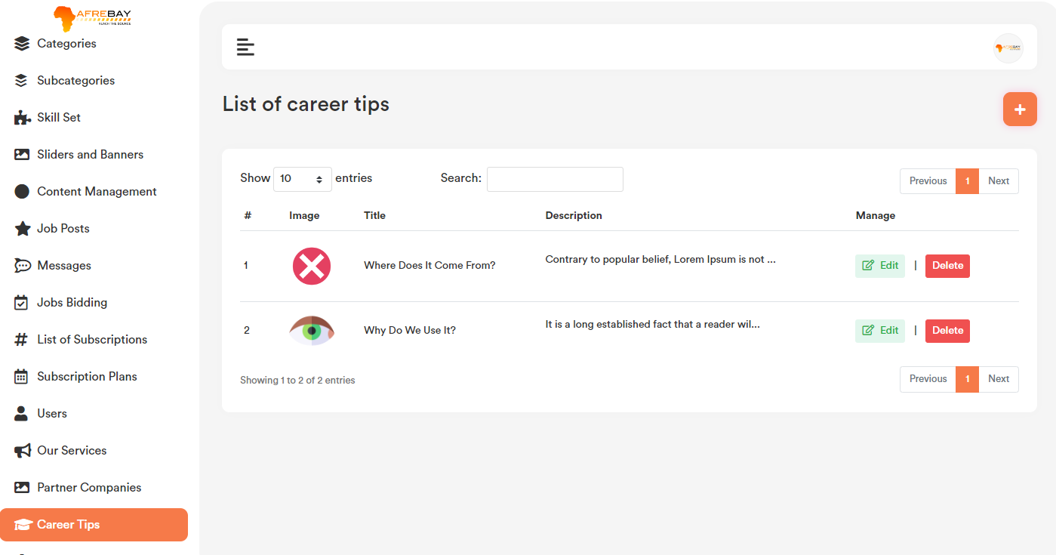

1. **Add Career Tips:**

Career tips list page top right corner click on the “+” icon. User will get a form to add new career tips. Please check the below screenshot.

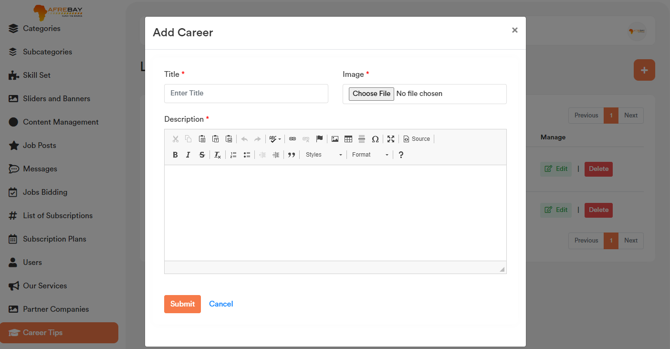

1. **Edit Career Tips:**

Career tips list page for each record if user click on the “Edit” option, it will open a form containing the existing data for that particular record. After making the change click on the “Save Changes” button. It will update the existing record will the updated data. Please check the below screenshot.

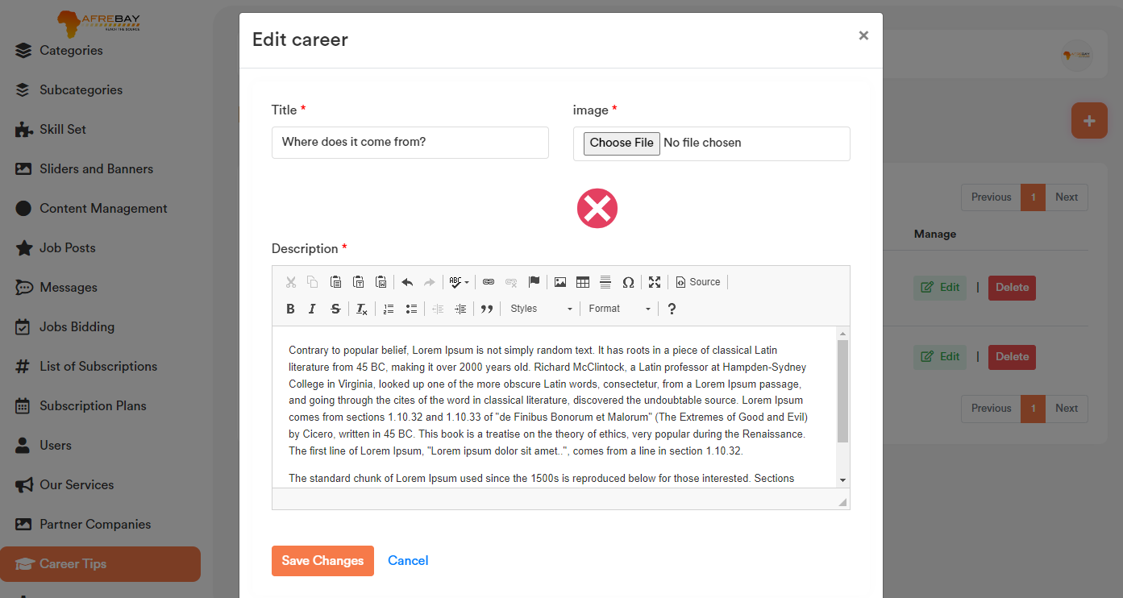

1. **Delete Career Tips:**

If user click on the “Delete” Button, admin will get a confirmation popup. Once confirm it will delete the related data.

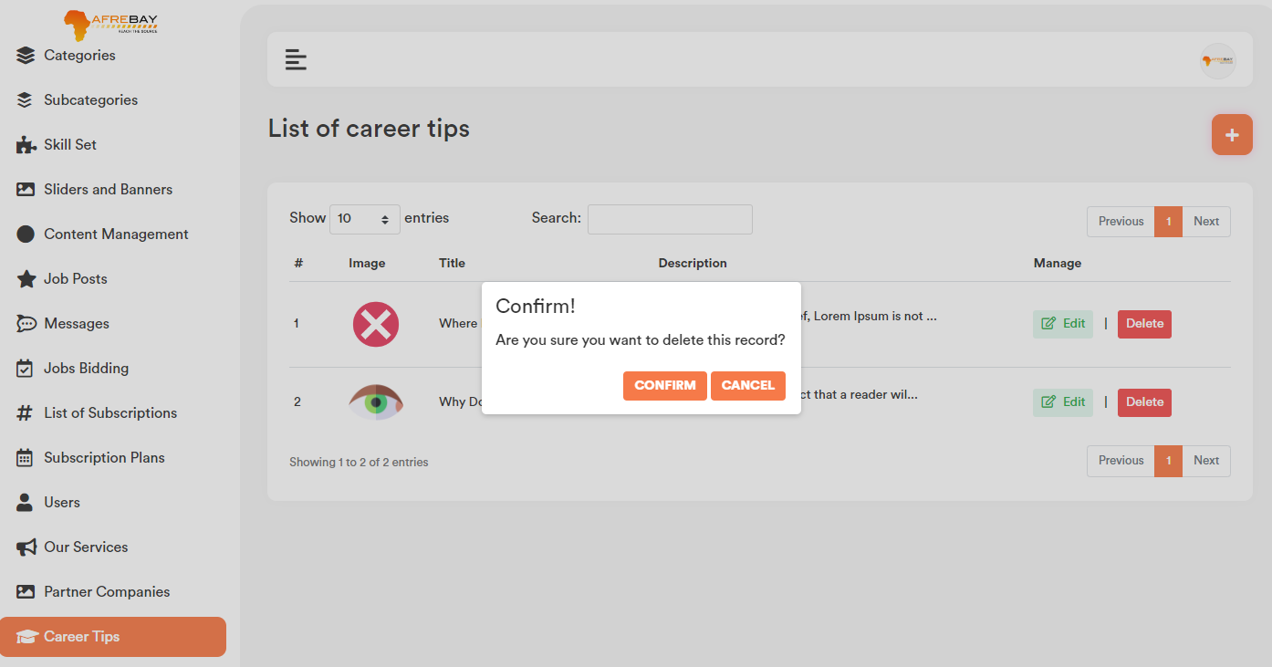

1. **Search Career Tips:**

User can search any record by typing text on the search textbox.

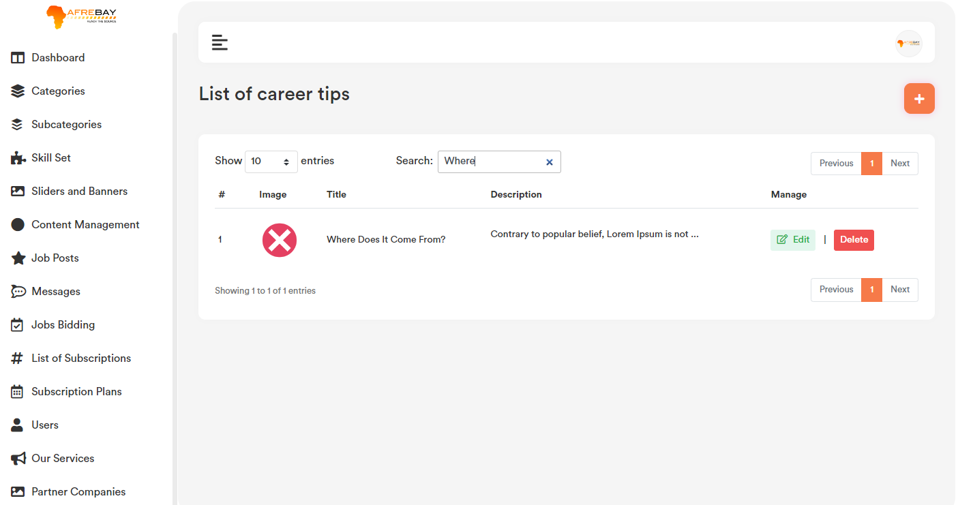

1. **Settings:**

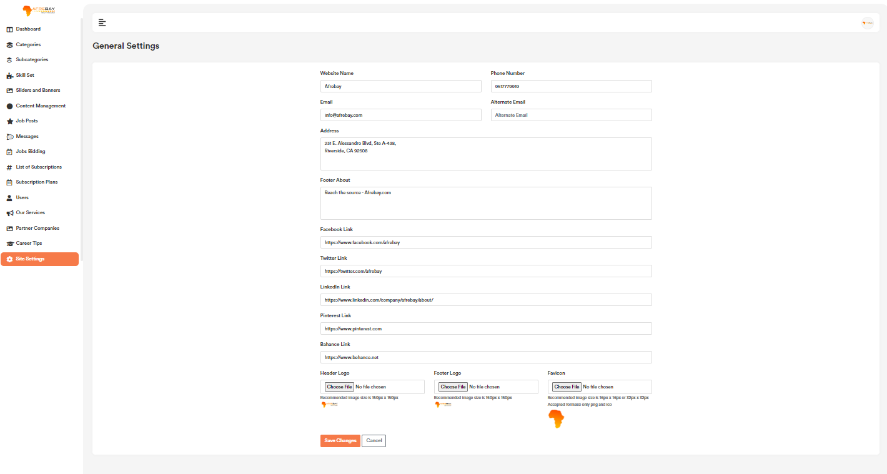

1. **Address:**

Address data will be visible on the website footer and contact us page.

1. **Social Media Link:** This data will bevisible on the website footer.
2. **Header Logo:** Header logo will bevisible on the website header top menu section.
3. **Footer Logo:** Footer logo will be visible on the website footer section.
4. **Favicon:** Favicon will be visible on the top of the browser ison.